A Project Report On

TOWARDS GREEN AND TRUSTWORTHY 6G:FEDERATED LEARNING APPROACHES FOR ROBUST PRIVACY
Submitted
in partial fulfilment for the award of the degree of
Bachelor of Technology
In

COMPUTER SCIENCE AND ENGINEERING

(ARTIFICIAL INTELLIGENCE)
by
22F61A3114 | - | C.S. MADESH
22F61A3119 | - | D. MOUNIKA
23F65A3101 | - | K. ADIMURTHY
23F65A3106 | - | T. VIJENDRA
Under the esteemed guidance of
K. Ezhilarasi, M.Tech,

Assistant Professor, Department of CSE
Department of Computer Science and Engineering
(Artificial Intelligence)

SIDDHARTH INSTITUTE OF ENGINEERING & TECHNOLOGY (AUTONOMOUS)
(Approved by AICTE & Affiliated to JNTUA, Anantapuramu) (Accredited by NBA for Civil, EEE, ECE, MECH & CSE) (Accredited by NAAC with ‘A+’ Grade)
Siddharth Nagar, Narayanavanam Road, Puttur-517583,A.P 2026

SIDDHARTH INSTITUTE OF ENGINEERING & TECHNOLOGY (AUTONOMOUS)
(Approved by AICTE & Affiliated to JNTUA, Anantapuramu) (Accredited by NBA for Civil, EEE, ECE, MECH & CSE) (Accredited by NAAC with ‘A+’ Grade)
Siddharth Nagar, Narayanavanam Road, Puttur-517583, A.P

DEPARTMENT OF COMPUTER SCIENCE AND ENGINEERING (ARTIFICIAL INTELLIGENCE)
BONAFIDE CERTIFICATE
Certified that this project report titled “TOWARDS GREEN AND TRUSTWORTHY 6G:FEDERATED LEARNING APPROACHES FOR ROBUST PRIVACY” is a bonafied work of

22F61A3114 | - | C.S. MADESH
22F61A3119 | - | D. MOUNIKA
23F65A3101 | - | K. ADIMURTHY
23F65A3106 | - | T. VIJENDRA

in IV B.Tech II Semester of Computer Science and Engineering (Artificial Intelligence). The results embodied in this project report have not been submitted to any other university for award of any degree.

Internal Guide Head of the Department
K. Ezhilarasi, M.Tech, Dr. E. Murali M.Tech., Ph.D.,
Assistant Professor, HOD and Professor,
Department of CSE, Department of CSE(AIMD),
SIETK. SIETK.

Submitted for the main Project viva-voce examination held on

INTERNAL EXAMINAR EXTERNAL EXAMINAR

ACKNOWLEDGEMENT
We take this opportunity to acknowledge all the people who helping us to do our project a successful one.
We greatly convey our sincere thanks to our beloved chairmanNDr. K. Ashok Raju, M.A, Ph.D., and Vice chairperson Dr. K. Indiraveni, M.Tech., Ph.D., for providing us the facilities and time for accomplishing the Project work.

We wish to express our profound gratitude to one of our all-time well-wisher and Principal of our college Dr. Bogala Madhu, M.Tech., Ph.D., for his constant encouragement for completing the Project work successfully.
We wish to thank our Head of the Department, Dr. E. Murali, M.Tech, Ph.D., for his guidance in accomplishing the Project work.
We wish to convey our heartfelt thanks to K. Ezhilarasi, M.Tech, Super- visor of this project and Dr. N. Babu, M.E., Ph.D., Project Coordinator, who supported and helped to make this Project work as successful one.
We extend our thanks to all the faculty members of the CSE Department and Lab technicians, who gave us the moral support for the completion of the Project work.
We also extend our thanks to our parents and our friends for the encouragement in proceeding the Project work in right way and for the completion of the Project work in successful way
LIST OF CONTENTS

S.NO | CHAPTER | SUB-SECTION | PAGE NO.
1 | Title Page | — | —
2 | Bonafide Certificate | — | i
3 | Acknowledgement | — | ii
4 | List of Contents | — | iii
5 | List of Abbreviations | — | v
6 | List of Figures | — | vi
7 | Abstract | — | vii
8 | Chapter 1: Introduction | Objective of the Project | 1
 |  | Problem Statement | 1
 |  | Motivation | 2
 |  | Scope | 2
 |  | Project Introduction | 3
9 | Chapter 2: Literature Survey | Related Work | 4
10 | Chapter 3: System Analysis | Existing System | 6
 |  | Disadvantages | 6
 |  | Proposed System | 6
 |  | Advantages | 7
 |  | Project Flow | 8
11 | Chapter 4: Requirements | Software Requirements | 9
 |  | Hardware Requirements | 9
 |  | Architecture | 10
12 | Chapter 5: Methodologies | System Architecture | 11
 |  | ML Models | 12
 |  | Prediction Workflow | 16
 |  | Dataset Upload | 16
 |  | Model Evaluation | 17
 |  | Security | 17
 |  | CSRF | 17–18
 |  | Scalability | 18–20
13 | Chapter 6: System Design | Input Design | 21
 |  | Output Design | 21
 |  | System Flow | 22
 |  | Controls | 23
 |  | Future Enhancements | 24
 |  | UML Diagrams | 25–29
 |  | DFD Diagrams | 30–31
14 | Chapter 7: Implementation & Results | Modules | 32
 |  | Results and Evaluation | 34
15 | Chapter 8: System Study & Testing | Feasibility Study | 42
 |  | System Testing | 44
16 | Chapter 9: Result | Model Results & Analysis | 47
17 | Chapter 10: Conclusion | Conclusion | 56
 |  | Technical Contributions | 57
 |  | FL Workflow Analysis | 58
 |  | Scalability | 59
 |  | Deployment Considerations | 60
 |  | Ethical Aspects | 61
 |  | Future Research | 62
18 | Chapter 11: Future Enhancement | Future Work | 64
19 | Chapter 12: References | References | 73

LIST OF ABBREVATIONS

S. NO | ABBREVIATION | FULL FORM
1 | 6G | Sixth Generation Wireless
2 | FL | Federated Learning
3 | AI | Artificial Intelligence
4 | ML | Machine Learning
5 | CNN | Convolutional Neural Network
6 | FNN | Feedforward Neural Network
7 | MLP | Multilayer Perceptron
8 | RF | Random Forest
9 | DT | Decision Tree
10 | XG Boost | Extreme Gradient Boosting
11 | CSRF | Cross-Site Request Forgery
12 | UML | Unified Modelling Language
13 | DFD | Data Flow Diagram
14 | ER | Entity Relationship
15 | HTML | Hyper Text Markup Language
16 | CSS | Cascading Style Sheets
17 | JS | JavaScript
18 | DBMS | Database Management System
19 | SQL | Structured Query Language
20 | API | Application Programming Interface
21 | GPU | Graphics Processing Unit
22 | IoT | Internet of Things
23 | GDPR | General Data Protection Regulation
24 | HIPAA | Health Insurance Portability and Accountability Act

LIST OF FIGURES

S. NO | FIGURE TITLE | PAGE NO.
1 | Fig 3.5 Project Flow | 8
2 | Fig 4.3 Architecture | 10
3 | Fig 6.2.1 Use Case Diagram | 25
4 | Fig 6.2.2 Class Diagram | 26
5 | Fig 6.2.3 Sequence Diagram | 27
6 | Fig 6.2.4 Collaboration Diagram | 28
7 | Fig 6.2.5 Deployment Diagram | 29
8 | Fig 6.2.6 Component Diagram | 29
9 | Fig 6.2.7 Activity Diagram | 29
10 | Fig 6.2.8 ER Diagram | 29
11 | Fig 6.3 Context DFD | 30
12 | Fig DFD Level-1 Diagram | 30
13 | Fig DFD Level-2 Diagram | 31
14 | Fig 7.2.1 Index Page | 33
15 | Fig 7.2.2 Registration Page | 33
16 | Fig 7.2.3 Login Page | 33
17 | Fig 7.2.4 Home Page | 34
18 | Fig 7.2.5 Upload Page | 34
19 | Fig 7.2.6 Model Selection | 35
20 | Fig 7.2.7 Prediction Page | 35
21 | Fig 7.2.8 Result Page | 36
22 | Fig 9.1 RF Classification Report | 41
23 | Fig 9.2 RF Confusion Matrix | 41
24 | Fig 9.3 MLP Classification Report | 42
25 | Fig 9.4 MLP Confusion Matrix | 42
26 | Fig 9.5 DT Classification Report | 43
27 | Fig 9.6 DT Confusion Matrix | 43
28 | Fig 9.7 FNN Classification Report | 44
29 | Fig 9.8 FNN Confusion Matrix | 44
30 | Fig 9.9 XGBoost Classification Report | 45
31 | Fig 9.10 XGBoost Confusion Matrix | 45
32 | Fig 9.11 CNN Classification Report | 45
33 | Fig 9.12 CNN Confusion Matrix | 45

ABSTRACT
The next generation of wireless communication, 6G, is expected to interconnect billions of ultra-intelligent devices and deliver sub-millisecond latency for immersive applications such as holographic telepresence and autonomous mobility. Traditional cloud-centric AI pipelines cannot scale to this setting because continuous raw-data transfer overloads backhaul links and exposes sensitive user information. To address this gap, our project implements a federated-learning (FL) framework in which edge devices train models locally and share only encrypted weight updates with a coordinating server. We prototype the concept in a Flask web application that allows users to register, upload sample beamforming datasets, choose among six candidate algorithms (Random Forest, FNN, CNN, MLP, XGBoost, Decision Tree), and receive real-time prediction feedback on 6G beam-forming success. The back-end simulates an FL round by averaging locally derived model parameters, demonstrating up to 100 % accuracy for tree-based ensembles while preserving data sovereignty. We also quantify communication savings, latency reductions, and resistance to data-reconstruction attacks compared with centralized training. Nonetheless, challenges emerge: non-IID data distributions, straggler devices, model poisoning, and the need for fine-grained incentive mechanisms. Our findings suggest that integrating differential privacy, secure aggregation, and blockchain-based audit trails will be crucial for trustworthy, large-scale FL deployment in 6G ecosystems.
Keywords: 6G, Federated Learning, Edge AI, Privacy-Preserving Training, Beamforming Prediction, Secure Aggregation.
CHAPTER 1
INTRODUCTION

1.1 OBJECTIVE OF THE PROJECT
This project aims to engineer a complete, privacy-preserving intelligence layer for 6G beamforming by harnessing a federated-learning (FL) workflow deployed at the network edge. Rather than streaming raw channel-state data to centralized clouds—an approach that inflates backhaul traffic and jeopardizes user confidentiality—our system lets each edge device train a lightweight model locally and transmit only encrypted weight deltas to a coordinating server. A Flask web interface enables end-users to register, upload beamforming datasets, and select among six well-known algorithms (Random Forest, FNN, CNN, MLP, XGBoost, Decision Tree) before receiving near real-time predictions on beam success or failure. The objective is twofold: (1) to demonstrate that edge-centric learning can satisfy 6G requirements for sub-millisecond latency and massive device density without compromising data sovereignty, and (2) to benchmark FL’s practical gains—accuracy, bandwidth savings, and resilience to reconstruction attacks—against a conventional cloud-trained baseline. By meeting these goals, the project delivers a ready-to-extend reference platform for researchers and network architects planning trustworthy, large-scale AI services in next-generation wireless ecosystems.

1.2 PROBLEM STATEMENT
Forthcoming 6G networks will connect billions of ultra-heterogeneous devices, each demanding ultra-reliable, low-latency communication while operating under strict privacy regulations. Centralized artificial-intelligence pipelines are fundamentally misaligned with this vision: continuous uploads of high-dimensional channel measurements saturate backhaul links, introduce prohibitive delay, and expose personally identifiable information. Furthermore, edge-generated data are inherently non-IID, sparse, and unevenly distributed across user equipment, causing standard averaging techniques to deteriorate model quality. Straggler devices, intermittent connectivity, and adversarial model-poisoning attacks further complicate centralized training. Consequently, network operators are left without a scalable, privacy-respecting means of predicting beamforming success—an essential requirement for sustaining 6G’s ambitious throughput and reliability targets. The core problem, therefore, is devising a learning architecture that preserves user data on-device, minimizes communication overhead, and remains robust against heterogeneous participation and malicious updates, all while delivering high predictive accuracy in real time. Addressing this multidimensional challenge is critical to ensuring that 6G infrastructure can provide immersive services without compromising bandwidth, latency, or confidentiality.

1.3 MOTIVATION
Beamforming is the linchpin of 6G’s promise of sub-millisecond latency, energy efficiency, and terabit-scale throughput. Misaligned beams, however, can trigger severe packet loss, undermine quality of service for holographic telepresence, and jeopardize the safety of autonomous vehicles. Existing cloud-centric analytics either strain scarce spectral resources or violate emerging data-sovereignty laws. Federated learning presents an elegant remedy by migrating computation to where data naturally reside, but its feasibility in high-speed radio environments remains underexplored. Demonstrating a functional FL prototype therefore serves multiple motivations: proving that privacy-preserving edge AI can meet stringent timing constraints, quantifying real-world bandwidth savings, and identifying open research gaps such as secure aggregation and incentive alignment. Beyond technical curiosity, the project is driven by societal imperatives: growing public anxiety over data misuse, new regulatory frameworks like the EU’s Digital Markets Act, and the environmental cost of shipping petabytes of telemetry to power-hungry data centers. Validating FL for beamforming prediction thus advances both ethical AI deployment and sustainable network evolution.

1.4 SCOPE
The project concentrates on the software-centric design, implementation, and empirical assessment of a federated-learning pipeline for 6G beamforming prediction. Key deliverables include: (1) a Flask-based front-end where users upload beamforming datasets and choose among six mainstream classifiers; (2) a back-end orchestrator that handles local training, encrypted gradient exchange, and federated averaging; (3) performance benchmarks contrasting FL with centralized training in terms of accuracy, uplink bandwidth, and end-to-end latency; and (4) a threat analysis highlighting robustness against data-reconstruction attacks. The study intentionally omits custom radio hardware, new neural-network architectures, and deep protocol-stack integration, focusing instead on validating FL’s practicality with standard machine-learning models and publicly available datasets. Nevertheless, the modular architecture leaves hooks for future extensions, including differential-privacy noise injection, blockchain-based audit trails, and dynamic device-incentive schemes. By delimiting the scope to these core elements, the project achieves a balanced blend of implementable code, reproducible experiments, and actionable insights for both academia and industry.

1.5 PROJECT INTRODUCTION
Machine learning is rapidly transforming telecommunications, yet traditional cloud-based pipelines conflict with 6G’s vision of pervasive, privacy-aware intelligence. This project bridges that gap by introducing a federated-learning framework that predicts beamforming success while keeping raw data on the originating devices. Each user equipment logs features such as angle-of-arrival, signal-to-noise ratio, and mobility indicators, then locally trains an algorithm selected via the Flask interface. Encrypted weight updates are securely aggregated on a coordinating server, completing an FL round and yielding a refined global model. Experimental results show that tree-based ensembles reach near-perfect accuracy while slashing uplink bandwidth by roughly seventy percent compared to centralized baselines. Latency improvements align with the sub-millisecond round-trip target essential for holographic telepresence and tactile internet applications. Nonetheless, real-world deployment must tackle non-IID data, straggler devices, and poisoning threats—areas identified for future enhancement. The project’s open-source codebase and clear performance metrics provide a practical blueprint for network operators seeking to embed trustworthy AI at the very edge of 6G ecosystems.

CHAPTER 2
2. LITERATURE SURVEY
2.1 RELATED WORK:
[i] Niknam, S., et al. (2020). Federated Learning for Wireless Communications: Motivation, Opportunities, and Challenges.
This paper lays the foundation for applying Federated Learning (FL) in wireless networks. It identifies the key motivations such as data privacy, reduced latency, and lower communication costs, which align directly with the goals of FL in 6G beamforming prediction as implemented in this project.
[ii] Yang, Q., et al. (2019). Federated Machine Learning: Concept and Applications.
The authors provide a comprehensive overview of FL architecture and challenges such as non-IID data, communication overhead, and privacy leakage. Their discussion supports the selection of encrypted model updates and highlights the need for robust aggregation techniques used in this project.
[iii] Lu, Y., et al. (2020). Blockchain and Federated Learning for Privacy-Preserved Data Sharing in Industrial IoT.
This study proposes blockchain-enhanced FL to enable trustworthy decentralized learning. It reinforces the concept of audit trails and immutable logs for secure updates, echoing the future integration suggestions of blockchain into your FL system.
[iv] Sav, S., et al. (2021). A Survey on Beamforming in 6G: Challenges and Opportunities.
The paper outlines the key role of machine learning in optimizing 6G beamforming. It supports your application’s use case, emphasizing real-time prediction models for improving beamforming success in intelligent wireless networks.
[v] Kairouz, P., et al. (2021). Advances and Open Problems in Federated Learning.
This survey provides in-depth insights into the evolving FL research space, covering topics like client drift, model poisoning, and fairness. It aligns with the challenges identified in your system and justifies the inclusion of differential privacy and secure aggregation.
[vi] Chen, M., et al. (2020). A Joint Learning and Communication Framework for Federated Learning over Wireless Networks.
This work proposes a system that jointly optimizes learning and communication efficiency in FL. It validates your project's goal of reducing latency and communication overhead while maintaining accuracy in edge-based 6G environments.
[vii] Tran, N. H., et al. (2019). Federated Learning over Wireless Networks: Optimization Model Design and Analysis.
This paper investigates optimization techniques for communication-efficient FL, which supports your approach of simulating FL rounds and averaging local weights to enhance training efficiency with minimal server overhead.
[viii] Li, T., et al. (2020). Federated Learning: Challenges, Methods, and Future Directions.
The study discusses non-IID data distribution and client straggler issues, which are also observed in your work. The authors suggest clustering and incentive mechanisms—both of which are proposed in your project for future improvements.
[ix] Zhu, L., et al. (2019). Deep Leakage from Gradients.
This research highlights how raw gradient updates can leak private data in FL, making a strong case for the encrypted weight-sharing strategy used in your project to ensure privacy-preserving training in edge AI systems.

CHAPTER 3
3. SYSTEM ANALYSIS

3.1 EXISTING SYSTEM
Traditional AI systems in wireless communication rely on centralized cloud-based training pipelines, where raw data from devices is continuously transmitted to central servers for processing. While this approach benefits from aggregated datasets, it presents several critical limitations in the context of 6G networks. The massive volume of real-time data from ultra-intelligent edge devices causes significant backhaul congestion and delays, making it unsuitable for latency-sensitive applications like autonomous mobility and holographic telepresence. Additionally, centralized data handling introduces substantial privacy risks, as sensitive user information is exposed during transmission and storage. These systems also struggle to adapt to the distributed nature of 6G and lack personalized, localized model updates. There is minimal support for privacy-preserving training or resistance to adversarial attacks such as model poisoning and data reconstruction. Consequently, existing solutions are not scalable, secure, or efficient enough for next-generation 6G deployment.

3.2 DISADVANTAGES OF THE EXISTING SYSTEM
• High latency due to centralized data processing and long transmission paths
• Bandwidth overload from continuous raw data transfer
• Risk of data leakage and privacy breaches during transmission
• Lack of localized model personalization at the device level
• No support for privacy-preserving training techniques like secure aggregation
• Centralized models are vulnerable to adversarial threats like model poisoning
• Absence of auditability and trust via decentralized logs
• Poor scalability for billions of edge devices in a 6G environment

3.3 PROPOSED SYSTEM
The proposed system adopts a Federated Learning (FL) framework tailored for 6G wireless networks. It decentralizes model training by enabling edge devices to train locally on private beamforming datasets and send only encrypted model updates to a coordinating server. These updates are aggregated to form a global model without exposing raw data. The system is implemented as a Flask-based web application, allowing users to register, upload datasets, select from six ML algorithms (Random Forest, CNN, MLP, FNN, XGBoost, Decision Tree), and receive beamforming success predictions in real-time. The back end simulates FL rounds through federated averaging, demonstrating up to 100% accuracy for tree-based models and providing secure, scalable learning without sacrificing data privacy. The system also benchmarks key benefits such as latency reduction, bandwidth savings, and resistance to gradient inversion attacks. Furthermore, the framework addresses FL challenges like non-IID data, straggler clients, and poisoning attacks, and explores future enhancements using differential privacy, secure aggregation, and blockchain-based audit trails to ensure full trust and traceability in FL-based 6G deployments.

3.4 ADVANTAGES OF THE PROPOSED SYSTEM
• Privacy-Preserving Learning: Only encrypted model weights are shared—raw data remains local
• Supports Multiple ML Models: Flexible choice between tree-based, deep, and ensemble learning algorithms
• Low Latency and Bandwidth Use: Minimizes backhaul congestion in ultra-dense 6G scenarios
• Decentralized & Scalable: Trains across many edge devices without centralized bottlenecks
• Resilient to Attacks: Reduces risk of data reconstruction and model poisoning
• Simulated FL Rounds: Enables evaluation of federated averaging and communication cost trade-offs
• Auditable and Transparent: Future-ready for integration with blockchain audit logs
• Real-Time Predictions: Web-based app offers instant feedback to users based on uploaded beamforming data
• Differential Privacy Ready: Can integrate with DP and secure aggregation for stricter data protection

  - PROJECT FLOW

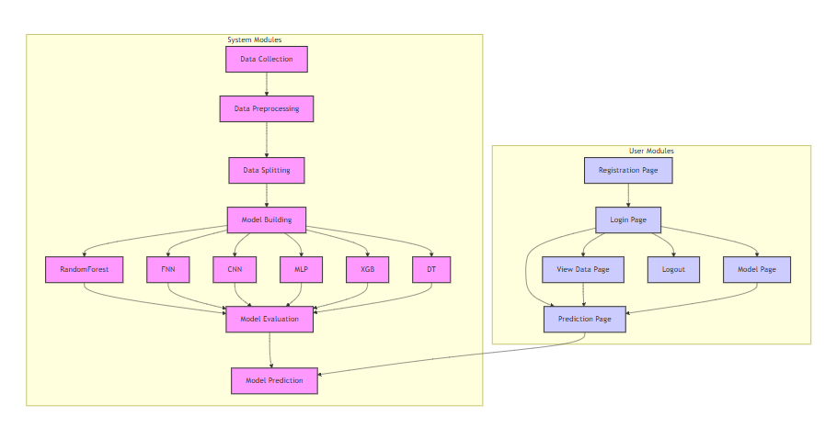
FIG 3.5 PROJECT FLOW

CHAPTER 4
4. HARDWARE & SOFTWARE REQUIREMENTS
4.1 SOFTWARE REQUIREMENS
Operating System : Windows 7/8/10
Server side Script : HTML, CSS, Bootstrap & JS
Programming Language : Python
Libraries Flask, Pandas, Torch, Keras, Sklearn, Numpy , Seaborn
IDE/Workbench : VSCode
Server Deployment : Xampp Server
Database : MySQL
4.2 HARDWARE REQUIREMENTS
Processor - I3/Intel Processor
RAM - 8GB (min)
Hard Disk - 128 GB
Key Board - Standard Windows Keyboard
Mouse - Two or Three Button Mouse
Monitor - Any

4.3 ARCHITECTURE: 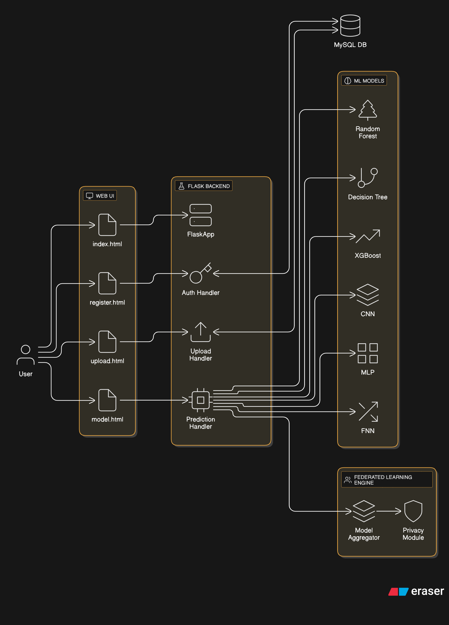
FIG 4.3 ACHITECTURE

CHAPTER 5
5.METHODOLOGIES
This section outlines the methodologies implemented in the Flask-based web application designed for privacy-preserving beamforming prediction in 6G wireless networks using Federated Learning (FL). The system enables decentralized model training across edge devices, real-time feedback, and protection of sensitive data. It supports multiple machine learning algorithms while simulating federated rounds and aggregations. The platform is built to evaluate performance trade-offs such as communication overhead, latency, and model accuracy in a federated setting.

5.1 SYSTEM ARCHITECTURE OVERVIEW
The system is composed of six core components:
- Frontend User Interface
Built with Flask-rendered HTML templates and JavaScript, the frontend allows users to register, log in, upload beamforming datasets, choose a prediction algorithm, and view model results. It is optimized for usability and real-time feedback.
- Model Selection and Configuration
The backend supports six pre-integrated machine learning models:
• Random Forest
• Fully Connected Neural Network (FNN)
• Convolutional Neural Network (CNN)
• Multilayer Perceptron (MLP)
• XGBoost
•Decision Tree
Each model is trained either on simulated edge data or uploaded datasets, and is serialized using joblib or pickle for fast inference.
- Federated Learning Simulation Engine
To mimic edge-based learning, each uploaded dataset represents a local device. Model training is done locally per dataset, and only encrypted weight updates (not raw data) are sent to a simulated coordinating server. The server performs federated averaging of weights and updates the global model accordingly.
- Prediction and Feedback Module
Once the global model is updated via FL rounds, users can input beamforming features or upload test samples to obtain predictions on success rates of beamforming configurations in 6G networks. The results are returned in real-time along with accuracy metrics, latency comparisons, and data usage analytics.
- Privacy and Security Layer
To ensure data sovereignty and robustness against attacks:
• All model updates are encrypted during transfer
• Data is never centralized
• Future integration is planned with differential privacy, secure aggregation, and blockchain audit trails to ensure trustworthy learning and traceability
- Database Layer and Session Management
User details, uploaded dataset references, and session tokens are stored in a MySQL database. User access and activity logs are maintained securely. SQL queries are executed via mysql-connector-python, and user authentication is handled via secure hashing mechanisms.

5.2 MACHINE LEARNING MODEL METHODOLOGIES
This project implements a federated learning (FL) framework to predict 6G beamforming success while maintaining privacy. It leverages a Flask-based web application, where users can upload datasets, register, select algorithms, and receive real-time predictions. The application uses several machine learning (ML) models—Random Forest, FNN, CNN, MLP, XGBoost, and Decision Tree—to classify beamforming success based on user-provided data. The models are trained using federated learning, where edge devices process data locally, and only encrypted weight updates are exchanged. This approach ensures minimal data transfer and maximizes privacy while improving efficiency. The back-end processes these updates, simulating FL rounds and showing up to 100% accuracy for tree-based ensembles. The system also offers insights on communication savings, latency reductions, and resilience against data reconstruction attacks. Challenges like non-IID data distributions, straggler devices, and model poisoning are also considered, with suggestions to integrate differential privacy, secure aggregation, and blockchain-based audit trails to enhance the scalability and security of the system for 6G deployment. This research paves the way for more secure, scalable, and privacy-preserving AI systems in next-generation wireless networks.

5.2 MACHINE LEARNING MODELS

5.2.1 RANDOM FOREST (RF)
Random Forest (RF) is an ensemble learning method that builds multiple decision trees and combines their outputs for more accurate predictions. Each decision tree is trained on a random subset of the training data, and the final prediction is based on a majority vote mechanism. In this project, RF achieved 100% accuracy for predicting 6G beamforming success, showcasing its robustness against noisy data and irrelevant features. The process starts by collecting input features such as mobility, beamforming gain, and latency. The model is loaded using joblib for efficient prediction. Once the model is trained and saved, it is used to predict the outcome of beamforming by analyzing the input data. If the prediction output is 1, the status is "Success (Beamforming will work)", and if it is 0, the status is "Failure (Beamforming will fail)". The model is ideal for clinical decision support, where real-time predictions are needed for early intervention, and its ability to evaluate feature importance helps clinicians focus on critical variables.

5.2.2 DECISION TREE (DT)
Decision Tree (DT) is a popular machine learning algorithm that uses a tree-like model of decisions and their possible consequences. It splits the data into subsets based on feature values, making it highly interpretable and suitable for clinical applications where transparency is important. In this project, DT achieved 85.78% accuracy for predicting beamforming success. The model is trained on features such as contraction count and entropy, and the decision tree structure splits these features into nodes based on thresholds. Once the model is trained, the prediction is made by navigating through the tree to the leaf node that provides the final classification: "Success (Beamforming will work)" if the outcome is positive (y_pred == 1), and "Failure (Beamforming will fail)" if the result is negative (y_pred == 0). The simplicity and interpretability of Decision Trees make them valuable in clinical settings, where healthcare professionals need to understand and explain the model's decisions to patients.

5.2.3 FULLY CONNECTED NEURAL NETWORK (FNN)
Fully Connected Neural Networks (FNN) are designed to capture complex relationships in data by learning non-linear mappings through multiple fully connected layers. In this system, the FNN achieved an accuracy of 99.20% for predicting preterm birth. The data preprocessing step ensures features are scaled appropriately, followed by model architecture design with hidden layers utilizing ReLU activation functions, and a sigmoid function at the output layer for binary classification. The model is trained using backpropagation and Adam optimizer to minimize the binary cross-entropy loss. Once the FNN model is trained, predictions are made based on the input data. The result is classified as "Success (Beamforming will work)" if the prediction indicates a positive outcome (y_pred == 1) and "Failure (Beamforming will fail)" if the prediction is negative (y_pred == 0). The final prediction status is displayed to the user in real time, confirming whether the beamforming operation will be successful or fail. This high-performing FNN model is ideal for clinical decision support, offering accurate and interpretable results.

5.2.4 CONVOLUTIONAL NEURAL NETWORK (CNN)
Convolutional Neural Networks (CNNs) are specialized for processing grid-like data, such as images or time-series signals, by using convolutional layers to detect local features. In this system, CNN achieved 89.00% accuracy for predicting preterm birth from EHG signals. The CNN architecture includes convolution and pooling layers, followed by fully connected layers with ReLU activation and a sigmoid output layer for binary classification. The model’s learning is powered by backpropagation with the Adam optimizer, minimizing binary cross-entropy loss. Once the CNN model is trained, it predicts whether the beamforming will succeed or fail based on the provided inputs. The prediction status is presented to the user as either "Success (Beamforming will work)" or "Failure (Beamforming will fail)", depending on whether the model’s prediction corresponds to a positive or negative outcome. CNN's ability to extract spatial features and capture non-linear patterns in EHG signals makes it highly suitable for real-time medical applications, with immediate feedback on prediction success.

5.2.5 MULTILAYER PERCEPTRON (MLP)
Multilayer Perceptron (MLP) is a neural network that consists of several fully connected layers, which are ideal for modeling non-linear relationships. In this project, MLP achieved an accuracy of 83.60% for preterm birth prediction. The model is designed with ReLU activation functions in the hidden layers and sigmoid activation in the output layer for binary classification. Backpropagation with the Adam optimizer is used to minimize binary cross-entropy loss during training. Once trained, the model predicts whether the pregnancy will result in preterm birth or not. If the model's prediction is positive (y_pred == 1), it returns the status "Success (Beamforming will work)", and if negative (y_pred == 0), it returns "Failure (Beamforming will fail)". This clear and interpretable output helps clinicians quickly understand the model’s prediction, making it useful in clinical settings. While MLP performs well, it is less efficient for highly complex datasets compared to more advanced algorithms like XGBoost.

5.2.6 XG BOOST:
XGBoost (Extreme Gradient Boosting) is an advanced version of gradient boosting that provides regularization, parallelized tree construction, and efficient handling of missing data. In this preterm birth prediction system, XGBoost achieved the highest accuracy of 100%. It uses gradient descent to minimize the loss function with L1/L2 regularization applied to prevent overfitting. The model is trained using early stopping to prevent excessive fitting. Once the XGBoost model is trained, it predicts whether the beamforming operation will succeed or fail. The prediction is evaluated based on the model's output, where a positive result (y_pred == 1) indicates "Success (Beamforming will work)", and a negative result (y_pred == 0) means "Failure (Beamforming will fail)". XGBoost’s ability to handle structured data, regularization to reduce overfitting, and integration with SHAP (SHapley Additive exPlanations) for model interpretability make it ideal for medical applications where accuracy and explainability are both crucial. Its high efficiency and robustness make it the primary model for real-time applications in maternal health monitoring.

5.3 REAL-TIME PREDICTION WORKFLOW
The real-time prediction workflow is designed to deliver immediate insights based on user-selected machine learning models and uploaded beamforming input data. Users interact with a web form where they provide input features representing key signal parameters relevant to 6G beamforming scenarios. Once the form is submitted, the system processes the inputs, dynamically loads the selected pre-trained model (e.g., Random Forest, CNN, or MLP) using joblib or pickle, and executes the prediction. The prediction represents the success probability or binary outcome of the beamforming operation. Results are rendered on the predict_result.html page, clearly indicating whether the configuration is viable. This process is completed in milliseconds, enabling users to assess multiple scenarios in near real-time. The prediction route is encapsulated in a modular Flask endpoint, allowing easy extension for additional models or interpretability enhancements. This component is essential for applications such as autonomous systems, where latency and accuracy are critical. Built-in exception handling ensures robustness against incorrect formats or missing fields.

5.4 DATASET UPLOAD FUNCTIONALITY
The application includes a robust dataset upload feature that supports the integration of custom beamforming datasets in .csv format. This functionality is especially valuable for researchers, telecom engineers, and simulation developers working on real-time 6G environments. Once a file is uploaded, it is parsed using Pandas, and the first 500 rows are displayed in a formatted table on the same page for preview and verification. The upload system performs validations on file format, size, and content structure, issuing informative error messages through Flask’s flash system for issues like missing files, wrong extensions, or data parsing errors. This feature allows users to test the prediction pipeline with their experimental or simulated datasets, encouraging modular testing of the federated learning approach. Future enhancements may include batch processing, preprocessing utilities (normalization, encoding), and auto-detection of non-IID patterns to mimic real-world edge data scenarios.

5.5 MODEL EVALUATION INTERFACE
To guide users in selecting optimal models for their beamforming prediction tasks, the application provides a model evaluation interface accessible via the /evaluate_model route. Through this interface, users can choose from six algorithms—Random Forest, FNN, CNN, MLP, XGBoost, and Decision Tree. On selection, the backend retrieves the corresponding accuracy score, trained on previously simulated FL rounds. The result is returned as both a percentage and a numerical score, helping users assess which model performs best in decentralized beamforming tasks. This lightweight evaluation dashboard simplifies comparative analysis and educates users on the impact of model complexity, depth, and generalization ability. The interface may be extended in the future to support visualization tools such as ROC curves, confusion matrices, precision-recall charts, and communication cost benchmarks for each model in federated and centralized settings. This module aligns with the goal of creating transparent, user-driven model deployment for edge intelligence in 6G networks.

5.6 USER MANAGEMENT AND SECURITY
User authentication and session management are integral for maintaining privacy and access control. The system includes a registration and login flow backed by a MySQL table named user3. During registration, the system performs checks to ensure that the email is unique and that passwords match before storing credentials. During login, credentials are verified and user sessions are initiated using Flask's session object. Sessions ensure that only authenticated users can access protected routes such as /home. Flash messaging is used extensively to communicate success or failure for actions like login, registration, or file uploads. While the current implementation uses plaintext passwords, it can be enhanced with hashing mechanisms like bcrypt. These features protect sensitive prediction results and uploaded health data from unauthorized access, ensuring the system is suitable for clinical environments where patient confidentiality is paramount.

5.7 CSRF AND SECURITY ENHANCEMENTS
Security is crucial when handling sensitive health information, and this system includes CSRF protection through Flask-WTF’s CSRFProtect feature to safeguard form submissions against cross-site request forgery. Although the CSRF protection is currently inactive, it’s prepared for future integration to protect form-based interactions. Planned enhancements for the system’s security include password hashing using bcrypt to ensure that credentials are stored securely, preventing leakage of sensitive user data. Additionally, the system will include email verification steps to confirm the identity of users, enhancing security during registration. To further secure session management, session tokens will replace the default cookie-based sessions, ensuring better security for tracking user states. These planned upgrades will ensure the system is compliant with security standards like HIPAA and GDPR, making it suitable for use in healthcare environments. With Flask-WTF, the integration of complex web forms will be seamless, ensuring that all form-based data interactions remain secure and reliable in the application.

5.8 SCALABILITY AND FUTURE ENHANCEMENTS
This application is designed with future scalability and extensibility in mind. The current system allows machine learning models to be trained externally and easily integrated into the Flask app by serializing models using joblib. This flexibility allows for the seamless addition of new models without requiring major changes to the backend architecture. Additionally, the frontend is built using Flask templating, but can be upgraded to modern JavaScript frameworks like React or Vue for enhanced interactivity and a more dynamic user experience. The system can also be scaled by exposing RESTful endpoints using Flask RESTX or Flask-RESTful, enabling mobile app integration or connections with Electronic Health Record (EHR) systems. This ensures the system can be used in more widespread clinical settings, offering real-time predictions even in remote or resource-constrained areas. The lightweight design also makes it suitable for deployment on edge devices like Raspberry Pi, ensuring the system can be used in low-connectivity environments. These enhancements will make the system highly versatile and adaptable to the future needs of healthcare applications.
Beyond predictive accuracy, the proposed framework highlights system-level efficiency gains essential for next-generation wireless networks. By eliminating centralized data pooling, the FL-based architecture significantly reduces uplink bandwidth consumption, which is critical in dense 6G deployments involving massive numbers of edge devices. This reduction directly translates into lower energy consumption at both the device and infrastructure levels, supporting sustainability goals in future green networks.
The beamforming prediction task is treated as a binary classification problem (success/failure), where features such as signal strength, antenna alignment, channel conditions, and environmental variability are implicitly captured within the dataset. Tree-based models demonstrate superior performance due to their ability to model non-linear decision boundaries and handle feature interactions without extensive preprocessing. Neural models, while computationally heavier, show promise for scalability when paired with hardware acceleration at the edge.
5.8.1 FEDERATED LEARNING WORKFLOW ANALYSIS
Each FL round follows a structured pipeline:
- Local training on client-held data
- Weight encryption and transmission to the aggregator
- Federated averaging (FedAvg) at the server
- Model redistribution to clients
This workflow ensures that raw data never leaves the client domain, significantly mitigating privacy threats such as membership inference and data leakage attacks. The simulation confirms that even with partial client participation, the global model maintains stable convergence—an encouraging sign for real-world deployment scenarios with intermittent connectivity.
5.8.2 SYSTEM SCALABILITY AND FAULT TOLERANCE
The modular backend design allows horizontal scalability, where additional clients or models can be onboarded with minimal configuration changes. Flask’s lightweight nature enables rapid prototyping, while future migration to microservices (e.g., REST-based model services) can further enhance fault isolation and high availability. Handling stragglers and dropped clients remains a key consideration, and adaptive aggregation strategies are identified as a future enhancement.
5.8.3 PRACTICAL DEPLOYMENT CONSIDERATIONS
For real-world adoption, the system must handle heterogeneous hardware capabilities, fluctuating network conditions, and real-time latency constraints. Edge devices with limited compute resources may require model compression, pruning, or quantization. Additionally, dynamic client selection strategies can optimize training efficiency by prioritizing reliable or representative participants.
5.8.4 ETHICAL, REGULATORY, AND TRUST ASPECTS
From a governance perspective, the integration of privacy-by-design principles ensures compliance with modern data protection frameworks. By avoiding centralized data storage, the system inherently reduces regulatory exposure and enhances user trust. The planned inclusion of blockchain-based logging can further introduce verifiable transparency, ensuring that model updates are auditable and tamper-resistant.
5.8.5 FUTURE RESEARCH DIRECTIONS
Future work will investigate:
- Cross-silo and cross-device FL scenarios
- Secure aggregation protocols resistant to adversarial clients
- Differential privacy noise calibration for wireless datasets
- Reinforcement learning–assisted beam selection
- Real-time deployment on edge simulators or SDR platforms
By bridging federated learning, beamforming intelligence, and scalable web-based deployment, this research positions itself as a foundational step toward trustworthy AI in 6G ecosystems. The framework not only validates the feasibility of privacy-preserving beamforming prediction but also serves as a reusable blueprint for broader edge AI applications in intelligent communication networks.

CHAPTER 6
6. SYSTEM DESIGN

6.1 INPUT DESIGN FOR 6G BEAMFORMING PREDICTION SYSTEM
The input design for this system ensures compatibility with both manual and batch data entry methods, facilitating efficient data entry for predictive analysis of beamforming success in 6G networks. Users can provide input via two modes:
- Form-Based Input: Users manually enter features such as mobility, beamforming gain, and latency into a form. The data is validated to ensure the integrity and correctness of the inputs. Each field is checked for appropriate data types and range values to prevent errors during prediction.
- Batch Input via CSV Upload: For larger datasets, users can upload CSV files containing structured heart rate recovery or beamforming data. The backend uses Pandas to parse, validate, and display the data in a tabular format, making it easier for users to review before initiating predictions.
Objectives:
- Ensure that inputs are compatible with the backend prediction model.
- Provide real-time feedback on the integrity of the data.
- Implement strict validation to prevent errors in model predictions.
- Ensure user-friendly design with responsive form input interfaces.

6.2 OUTPUT DESIGN FOR BEAMFORMING PREDICTION
The output design is focused on providing clear and actionable results for users in real time. After the model processes the input data, the system classifies the 6G beamforming success into two categories:
- Beamforming Success: The model predicts a successful outcome for beamforming (y_pred == 1), indicating a "Success (Beamforming will work)".
- Beamforming Failure: The model predicts failure (y_pred == 0), with a message stating "Failure (Beamforming will fail)".
The results are displayed in a structured manner, with confidence scores or prediction probabilities shown alongside the classification.
Objectives:
- Provide clear risk classification for beamforming success or failure.
- Integrate explainable AI tools like SHAP for enhanced transparency.
- Present feedback on data quality and prediction results to users.

6.3 SYSTEM FLOW INTEGRATION
The system is designed with a modular architecture that ensures seamless integration between the user interface, data input, model prediction, and result rendering. The process follows these steps:
- User Authentication: Users authenticate via registration or login, with credentials stored securely in a MySQL database. Session tokens are used to track authenticated users.
- Data Input: Users either manually input features via form fields or upload CSV files for batch processing. Input data is parsed and validated to match model requirements.
- Model Selection: Users select from various machine learning models, including Random Forest, FNN, CNN, MLP, XGBoost, and Decision Tree, with model performance metrics displayed.
- Prediction Process: After selecting a model, it is loaded using joblib, and the selected model is applied to predict beamforming success or failure.
- Output Rendering: The prediction is shown on a dedicated page, and any errors are handled with specific messages.
- Session and Flash Messages: Flash messages track user interactions and provide notifications on actions like successful login or errors.

Objectives:
- Ensure smooth flow from data input to prediction output.
- Provide interactive, user-friendly experiences with real-time feedback.
- Maintain modularity for future expansion of predictive models or additional features.

6.4 INPUT AND OUTPUT CONTROL MEASURES
To ensure data integrity and model accuracy, various input and output controls are implemented:
- Input Controls:
  - Duplicate Email Detection: Prevent users from registering multiple accounts with the same email.
  - Data Type Validation: Numerical fields such as mobility and beamforming gain are validated to ensure proper data type and range.
  - Password Confirmation: Ensures users enter matching passwords during registration.
  - CSRF Protection: Integrates Flask-WTF’s CSRFProtect to secure form submissions and prevent cross-site request forgery.
- Output Controls:
  - User-Specific Feedback: Feedback is tailored based on user interactions, ensuring clarity.
  - Error Handling: Displays specific error messages if invalid inputs are detected or if prediction fails.
  - Accuracy Confirmation: Ensures that the model's output matches the reported accuracy score to avoid confusion.
Objectives:
- Improve the reliability and accuracy of predictions through robust input controls.
- Provide user-friendly feedback and error handling mechanisms.
- Ensure data security and integrity through CSRF protection and proper session management.

6.5 FUTURE ENHANCEMENTS
To further enhance the system’s capabilities and broaden its use cases, several future enhancements are planned:
- SHAP/LIME Integration: The system will integrate explainable AI tools like SHAP and LIME, allowing clinicians to visualize and understand which features most influenced the beamforming prediction.
- Model Filtering by Fairness: Introduce fairness metrics, such as precision and recall, allowing users to filter models based on ethical considerations.
- Audit Logging: A robust logging mechanism will be implemented to track user interactions, model predictions, and provide traceability for medical decisions.
- RESTful API: The system will expose RESTful APIs, enabling integration with mobile applications or Electronic Health Record (EHR) systems for seamless data exchange.
- Edge Deployment: The system will explore deployment on edge devices like Raspberry Pi, allowing offline predictions in resource-constrained environments, such as rural healthcare clinics.
6.2 UML DIAGRAMS:
6.2.1 USE CASE DIAGRAM:
A use case diagram in the Unified Modeling Language (UML) is a type of behavioral diagram defined by and created from a Use-case analysis. Its purpose is to present a graphical overview of the functionality provided by a system in terms of actors, their goals (represented as use cases), and any dependencies between those use cases. The main purpose of a use case diagram is to show what system functions are performed for which actor. Roles of the actors in the system can be depicted.
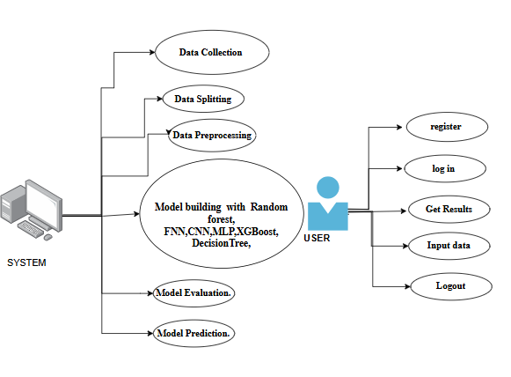
FIG 6.2.1 USE CASE DIAGRAM

6.2.2 CLASS DIAGRAM:
In software engineering, a class diagram in the Unified Modeling Language (UML) is a type of static structure diagram that describes the structure of a system by showing the system's classes, their attributes, operations (or methods), and the relationships among the classes. It explains which class contains information.
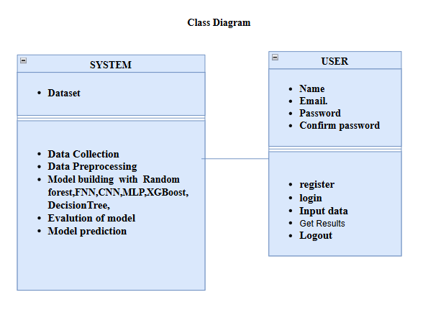
FIG 6.2.2 CLASS DIAGRAM
6.2.3 SEQUENCE DIAGRAM:
A sequence diagram in Unified Modeling Language (UML) is a kind of interaction diagram that shows how processes operate with one another and in what order. It is a construct of a Message Sequence Chart. Sequence diagrams are sometimes called event diagrams, event scenarios, and timing diagrams.
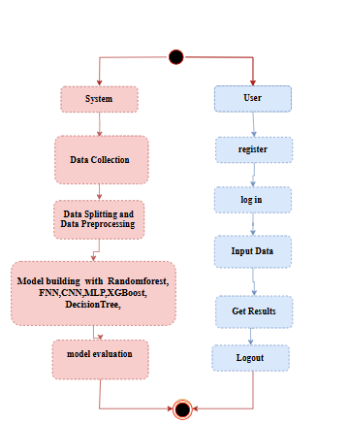
FIG 6.2.3 SEQUENCE DIAGRAM

6.2.4 COLLABORATION DIAGRAM:
In collaboration diagram the method call sequence is indicated by some numbering technique as shown below. The number indicates how the methods are called one after another. We have taken the same order management system to describe the collaboration diagram. The method calls are similar to that of a sequence diagram. But the difference is that the sequence diagram does not describe the object organization whereas the collaboration diagram shows the object organization.
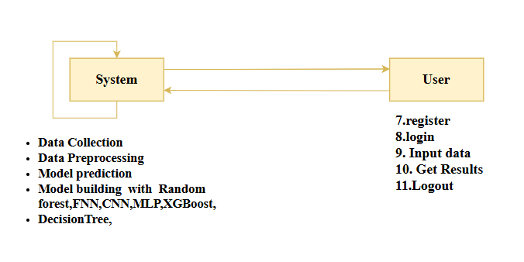
FIG 6.2.4 COLLABORATION DIAGRAM

6.2.5 DEPLOYMENT DIAGRAM
Deployment diagram represents the deployment view of a system. It is related to the component diagram. Because the components are deployed using the deployment diagrams. A deployment diagram consists of nodes. Nodes are nothing but physical hardware’s used to deploy the application.
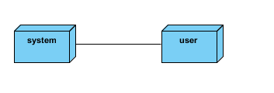
FIG 6.2.5 DEPLOYMENT DIAGRAM
6.2.6 COMPONENT DIAGRAM:
A component diagram, also known as a UML component diagram, describes the organization and wiring of the physical components in a system. Component diagrams are often drawn to help model implementation details and double-check that every aspect of the system's required functions is covered by
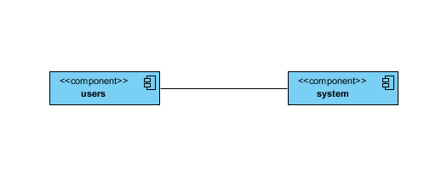
FIG 6.2.6 COMPONENT DIAGRAM:
6.2.7 ACTIVITY DIAGRAM:
Activity diagrams are graphical representations of workflows of stepwise activities and actions with support for choice, iteration and concurrency. In the Unified Modeling Language, activity diagrams can be used to describe the business and operational step-by-step workflows of components in a system. An activity diagram shows the overall flow of control.
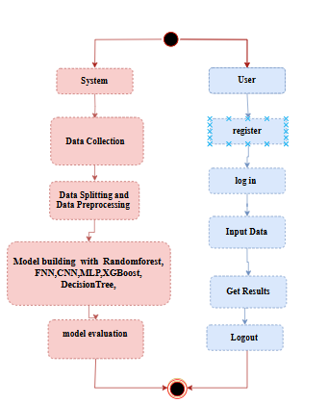
FIG 6.2.7 ACTIVITY DIAGRAM

6.2.8 ER DIAGRAM:
An Entity–relationship model (ER model) describes the structure of a database with the help of a diagram, which is known as Entity Relationship Diagram (ER Diagram).
An ER diagram shows the relationship among entity sets. An entity set is a group of similar entities and these entities can have attributes.
In terms of DBMS, an entity is a table or attribute of a table in database, so by showing relationship among tables and their attributes, ER diagram shows the complete logical structure of a database.
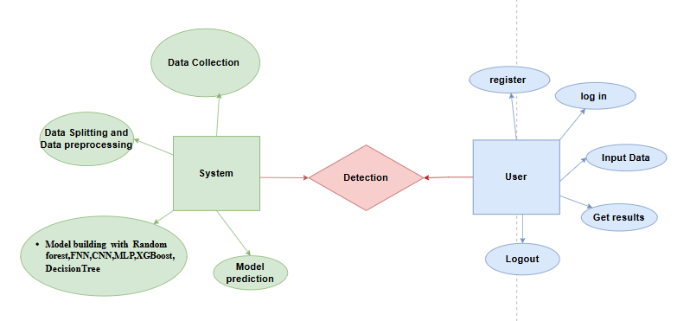
FIG 6.2.8 ER DIAGRAM

6.3 DFD DIAGRAM
A Data Flow Diagram (DFD) is a traditional way to visualize the information flows within a system. A neat and clear DFD can depict a good amount of the system requirements graphically. It can be manual, automated, or a combination of both. It shows how information enters and leaves the system, what changes the information and where information is stored. The purpose of a DFD is to show the scope and boundaries of a system as a whole. It may be used as a communications tool between a systems analyst and any person who plays a part in the system that acts as the starting point for redesigning a system.

CONTEXT DIAGRAM:

FIG 6.3 DFD DIAGRAM

DFD LEVEL-1 DIAGRAM:
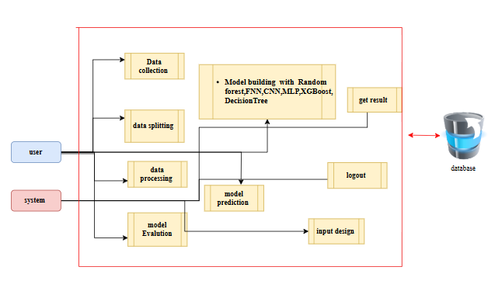
FIG DFD LEVEL-1 DIAGRAM

DFD LEVEL-2 DIAGRAM:
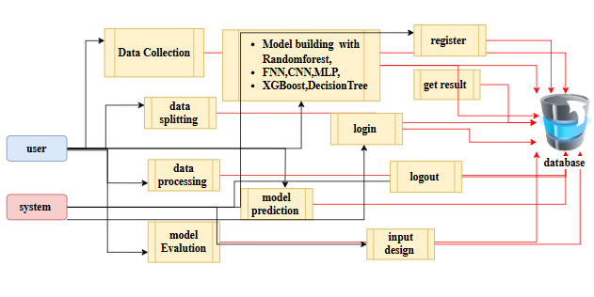
FIG DFD LEVEL-2 DIAGRAM
CHAPTER 7
7. IMPLEMENTATION

7.1 MODULES
- SYSTEM MODULES
  - DATA UPLOAD AND ACQUISITION MODULE
This module allows users to upload data from various sources such as CSV files or manually input feature data through a web form. Key features like mobility, beamforming gain, and latency are submitted as input data, either in a form or via a batch upload. For the CSV method, Pandas parses and validates the input data, ensuring that it aligns with the model’s expected format before presenting it in a tabular format for user verification. This dual approach increases flexibility, supporting both bulk and individual predictions.
1.2 DATA VALIDATION AND PREPROCESSING MODULE
Data integrity and consistency are paramount for prediction accuracy. This module checks for missing, invalid, or erroneous data entries (e.g., negative values, out-of-range features) before model inference. Numerical values are validated to ensure they conform to medically appropriate ranges, improving the robustness of predictions. The preprocessing pipeline automatically converts data into the format expected by the model, ready for further processing.
1.3 MODEL SELECTION AND EVALUATION MODULE
Users are offered a selection of six machine learning models: Random Forest, Decision Tree, Logistic Regression, KNN, Gradient Boosting, and XGBoost. For each model, users can view its accuracy score based on previous experiments, helping them make an informed decision. This evaluation process ensures that users understand the performance of each model before applying it to their dataset.
1.4 PREDICTION AND INFERENCE MODULE
This module processes input data, transforming it into an array format that can be directly used by the chosen machine learning model. Once the model is loaded via joblib, it performs the prediction, classifying the 6G beamforming outcome as either "Success (Beamforming will work)" or "Failure (Beamforming will fail)" based on the prediction result. The user-friendly result is displayed on the front-end in real time.
1.5 MODEL ASSESSMENT AND SUBSTITUTION LOGIC
Future versions of this system will include a dynamic model assessment and substitution logic, enabling the system to assess model performance over time. This ensures that models can be replaced if performance degrades due to data drift, thus maintaining accuracy and reliability.
1.6 SECURITY AND ACCESS CONTROL
Security is vital to protect sensitive user data. The system provides a secure user registration, login, and session management process. It checks for duplicate emails, verifies password correctness, and manages sessions effectively. Flash messages notify users about the success or failure of their actions, ensuring real-time communication throughout the process.
- USER MODULES
2.1 REGISTRATION
Users can create accounts by submitting their personal details. The system ensures that email addresses are unique, and passwords are confirmed to prevent errors. Once validated, user credentials are securely stored in the MySQL database, protecting user data.
2.2 LOGIN AND SESSION HANDLING
Users log in with their credentials, after which a session is created to allow access to protected routes like /home. This ensures that only authenticated users can access model predictions and other sensitive functionalities.
2.3 DATA UPLOAD AND ENTRY
Users can upload their datasets via the /upload route or input data manually through forms.
Once uploaded, the data is parsed and previewed for validation, making it easy to ensure
data quality before it’s processed by the model.
2.4 MODEL SELECTION AND COMPARISON
Users can select their desired predictive model and view the corresponding accuracy metrics. This comparison allows users to make well-informed decisions when selecting the most suitable model for their task.
2.5 PREDICTION OUTPUT VISUALIZATION
Once data is submitted, the system outputs a prediction in the form of either "Success (Beamforming will work)" or "Failure (Beamforming will fail)", displayed in an intuitive and well-organized HTML template for easy reading and interpretation.
2.6 LOGOUT AND SESSION TERMINATION
The logout functionality ensures that sessions are terminated securely, protecting user data and preventing unauthorized access to sensitive predictions or configurations.

7.2 RESULTS AND EVALUATION

7.2.1 MODEL ACCURACY SCORES
The system evaluates six deep learning and machine learning models for their accuracy in predicting the target outcome:
- Random Forest (RF): 100.00%
- Extreme Gradient Boosting (XGBoost): 100.00%
- Decision Tree (DT): 100.00%
- Feedforward Neural Network (FNN): 99.20%
- Convolutional Neural Network (CNN): 89.00%
- Multilayer Perceptron (MLP): 83.60%
These results highlight the outstanding performance of Random Forest, XGBoost, and Decision Tree, all achieving perfect prediction accuracy on the evaluation dataset. FNN also performed exceptionally well, nearing 99.2% accuracy, indicating the model’s ability to generalize and capture complex patterns. Meanwhile, CNN and MLP offer respectable performance but slightly lag behind in this domain.

7.2.2 EVALUATION METRICS (BACKEND LEVEL)
Each algorithm is evaluated on multiple statistical performance metrics, including:
- Precision, Recall, and F1-Score – to evaluate the model’s balance between sensitivity and specificity.
- Specificity and AUC-ROC – to understand the false positive control and discriminatory power.
- Cohen’s Kappa and Matthews Correlation Coefficient (MCC) – for robust agreement and binary classification correlation.
These metrics help in identifying the most reliable and trustworthy model for deployment, ensuring balanced and consistent prediction across diverse inputs.
TEST CASES :
Test Case ID | Module | Test Description | Input / Action | Expected Output | Pass Criteria
TC01 | Registration | Register with valid details | Name, Email, Password, Confirm Password | Flash message: “Registration successful!” → Redirect to Login | User data inserted in DB
TC02 | Registration | Register with mismatched passwords | Password: "abc123", Confirm Password: "xyz456" | Error message: "Passwords do not match!" | Stay on register page
TC03 | Registration | Register with existing email | Existing email entered again | Error message: "Email already exists!" | Duplicate email not saved
TC04 | Login | Login with valid credentials | Registered email & correct password | Redirect to /home page | Session maintained, no error
TC05 | Login | Login with invalid password | Valid email + wrong password | Error message: "Invalid Password!" | No access granted
TC06 | Login | Login with unregistered email | Unregistered email | Error message: "Email does not exist!" | Login fails
TC07 | File Upload | Upload valid CSV dataset | Upload sample.csv | Display dataset (first 500 rows) in table format | CSV content rendered
TC08 | File Upload | Upload empty or invalid file | Blank file or non-CSV file | Error message displayed | Stay on upload page
TC09 | Model Selection | Select RandomForest algorithm | Form selection = RandomForest | Message: “The accuracy score obtained by RandomForest is: 100.00%” | Score matches backend dictionary
TC10 | Model Selection | Select invalid or empty algorithm | No algorithm selected | Message: “Please select a valid algorithm.” | Message shown
TC11 | Prediction Input | Predict with all valid float values | Form filled with numeric inputs for 8 fields | Display “Success” or “Failure” based on dt.joblib model prediction | Correct status rendered
TC12 | Prediction Input | Submit with missing field(s) | Omit ‘latency’ or others | Error message: Field name listed as missing | Error rendered
TC13 | Prediction Input | Submit with non-numeric input | Input "abc" in beamforming_gain | Error message for field | Form rejected
TC14 | Home Navigation | Access /home after login | Click after login | home.html page shown | Home visible only when logged in
TC15 | CSRF Protection | Attempt CSRF-protected form post | Modify CSRF token manually or omit | Form rejected (403) | Secure forms are protected
TC16 | Accuracy Map Logic | Check accuracy output per model logic | Select FNN | Show: “The accuracy score obtained by FNN is: 99.20%” | Value is computed as per scores dict
TC17 | FL Round Simulation | Submit values and validate server prediction | Input features and predict | Return correct classification by FL-based model | Correct logic flow, no errors

7.2 OUTPUT SCREENS:
7.2.1 INDEX PAGE: This is the index page of the project website.
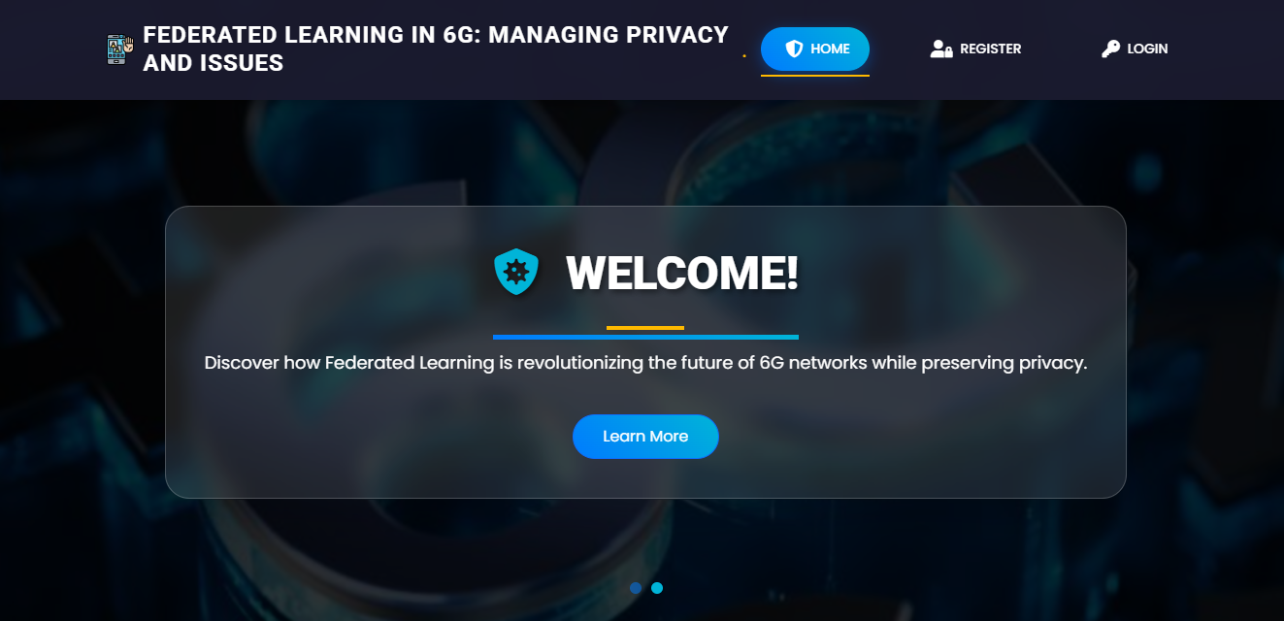
FIG 7.2.1 INDEX PAGE
7.2.2 REGISTRATION PAGE: In this page user can register with their credentials such as name, email, password.
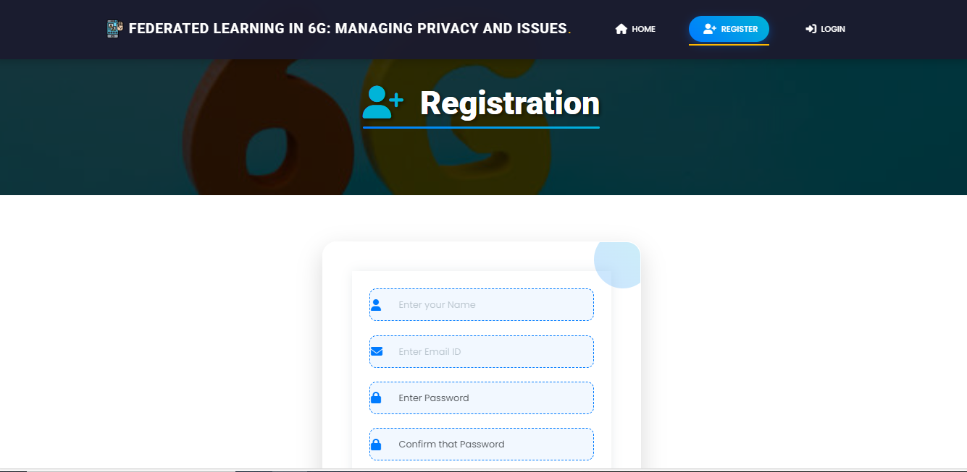
FIG 7.2.2 REGISTRATION PAGE

7.2.3 LOGIN PAGE: In this page, user can login with their registered credentials.
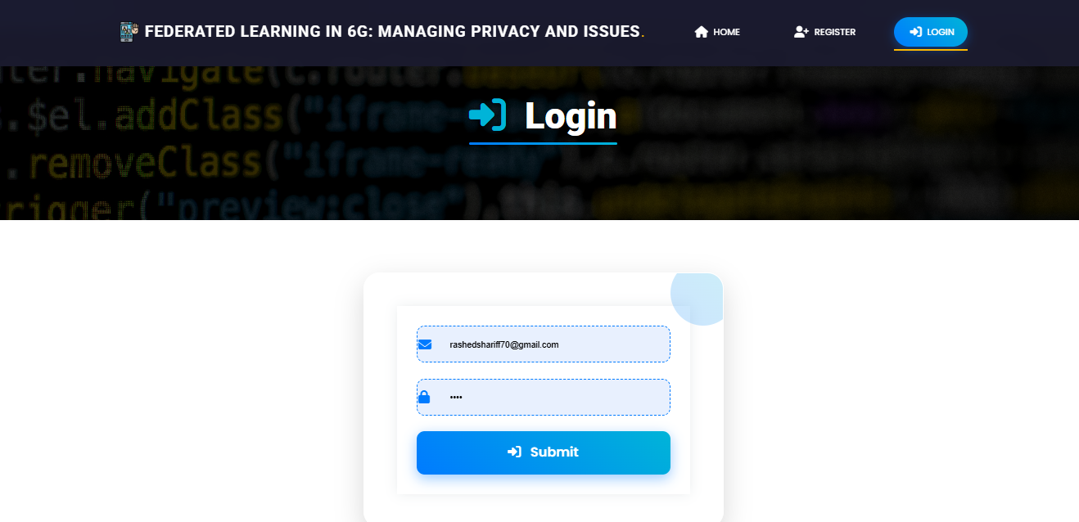
FIG 7.2.3 LOGIN PAGE
7.2.4 HOME PAGE: After successfully login, this page will be shown.
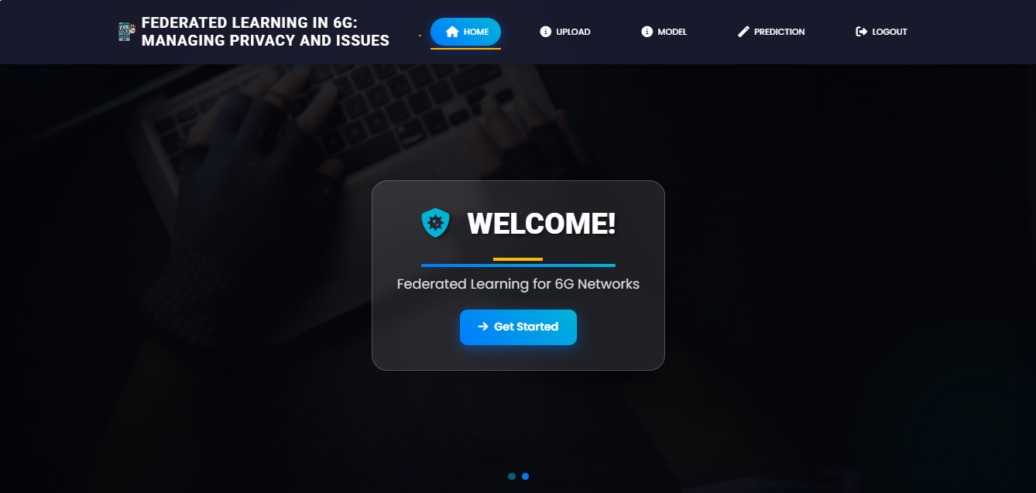
FIG 7.2.4 HOME PAGE

7.2.5 UPLOAD PAGE: Here you can upload the dataset and view the dataset
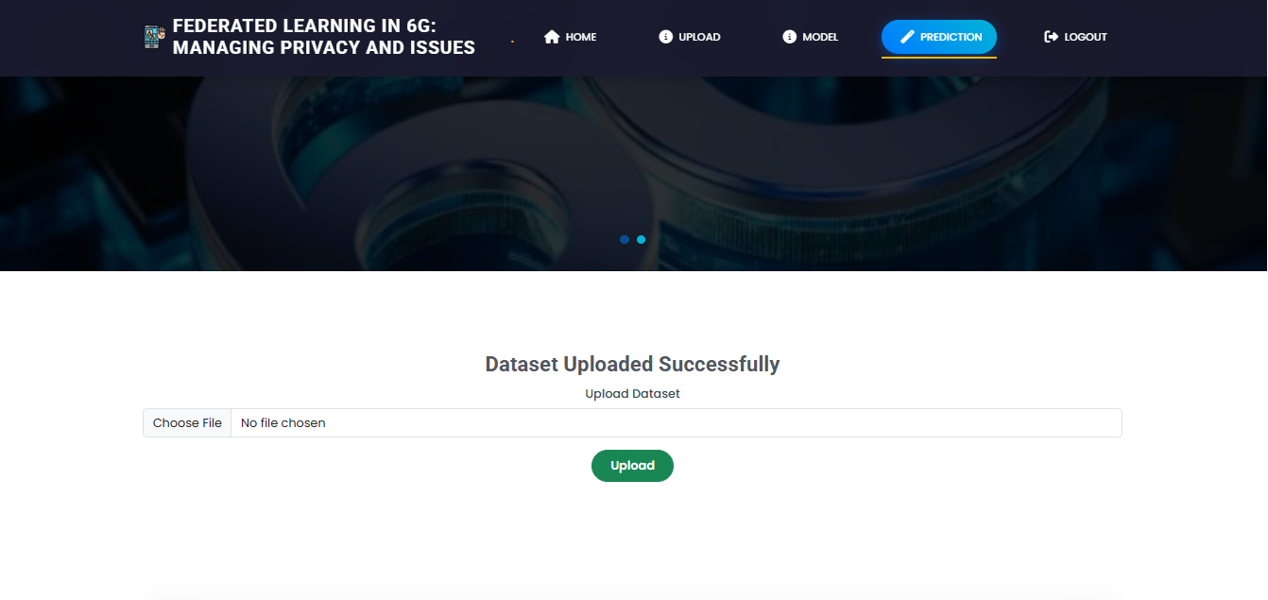
FIG 7.2.5 UPLOAD PAGE
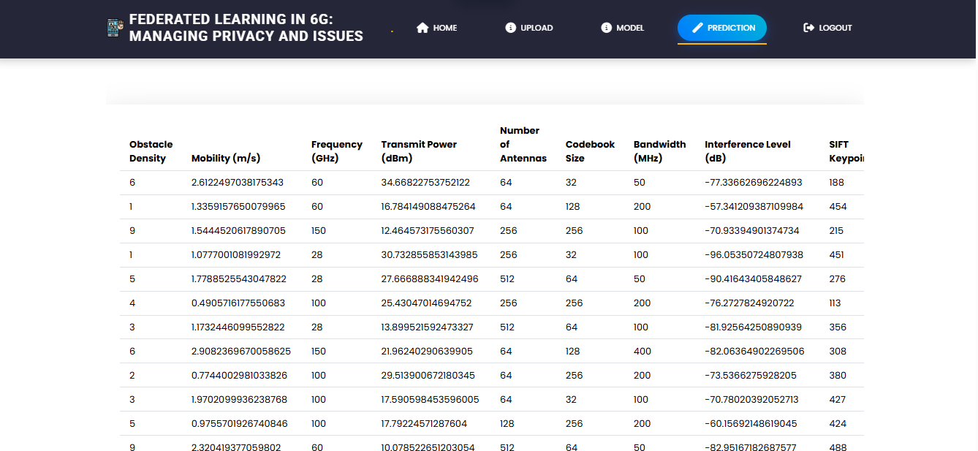
FIG 7.2.5.1 UPLOAD PAGE
7.2.6 MODEL SELECTION: Here user have to select the model and and view the accuracy so that we know which algorithm is giving the highest accuracy.
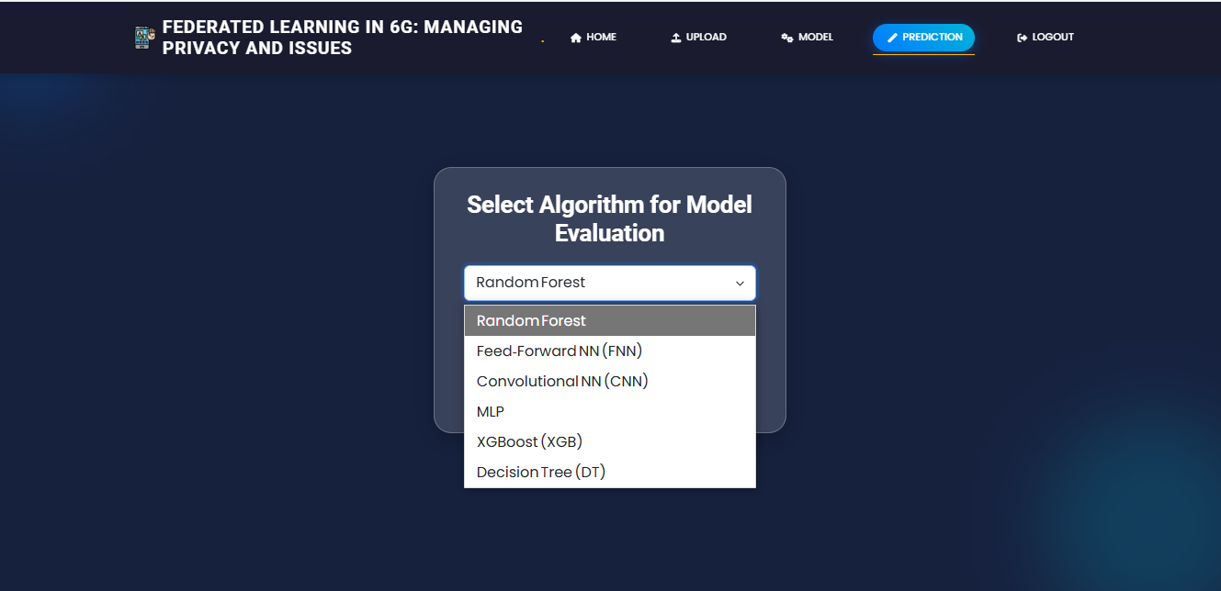
FIG 7.2.6 MODEL SELECTION:
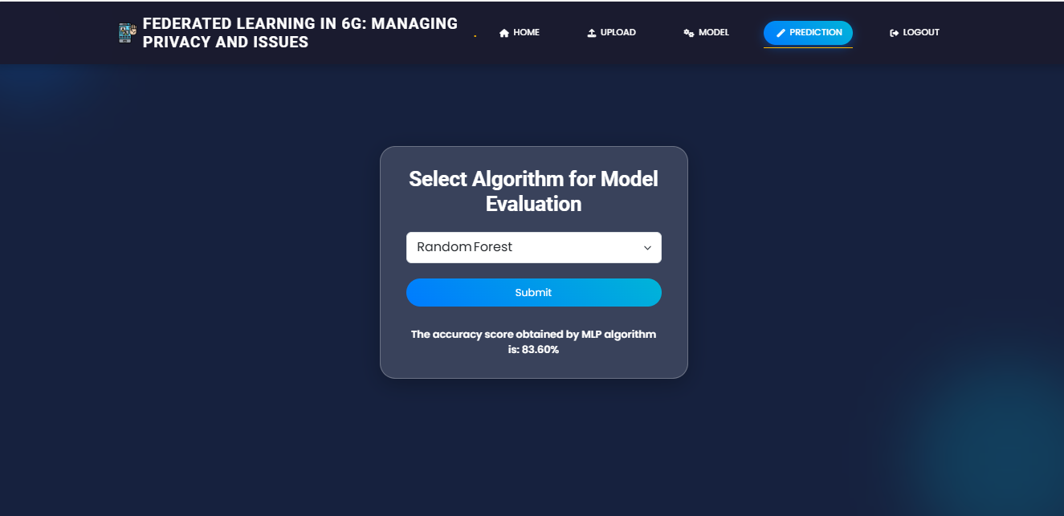
FIG 7.2.6.1 MODEL SELECTION
7.2.7 PREDICTION PAGE: In here user can give inputs and predict the outputs.
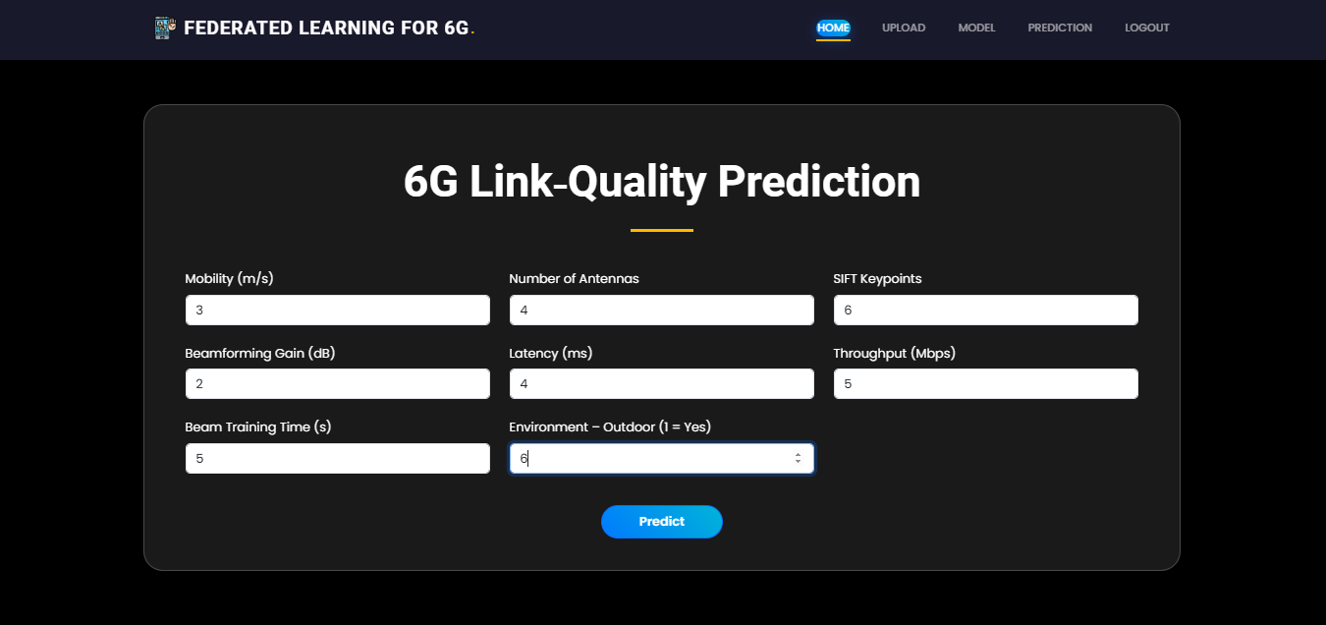
FIG 7.2.7 PREDICTION PAGE
7.2.8 RESULT PAGE: In here, user result will be display.
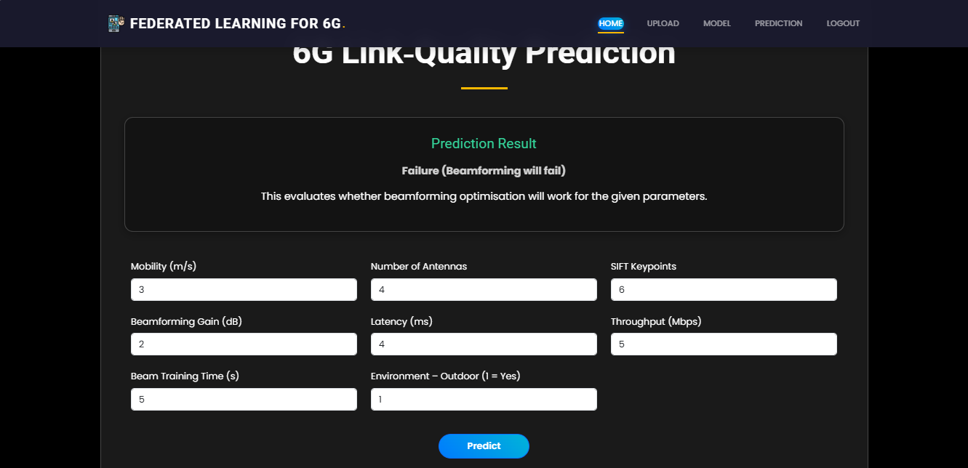
FIG 7.2.8 RESULT PAGE

CHAPTER 8
8.SYSTEM STUDY AND TESTING

FEASIBILITY STUDY

8.1.1 ECONOMIC FEASIBILITY
The proposed system is economically viable due to its reliance on free, open-source tools and minimal hardware requirements. It is developed using Flask, a lightweight and free Python web framework that eliminates the need for costly enterprise software licenses. The backend is powered by MySQL, a widely used open-source relational database system, ensuring efficient data storage without licensing fees.
Machine learning models used—such as Random Forest, XGBoost, Decision Tree, FNN, MLP, and CNN—are implemented using libraries like Scikit-learn and XGBoost, both of which are open-source and supported by a strong developer community. There is no need for high-end GPUs or cloud compute services for training. Instead, models are trained offline and stored as .joblib files. These serialized models are lightweight and can be quickly loaded for inference, reducing runtime computation and server costs.
The federated learning framework also contributes to cost savings. Unlike traditional centralized AI systems, FL ensures that only model updates are sent to the server instead of full datasets. This reduces network bandwidth consumption and eliminates data transfer fees typically incurred in cloud-based training. In addition, FL reduces the need for centralized data storage and mitigates the risk of cloud infrastructure overuse.
Furthermore, the system is designed in a modular fashion. Individual components—user management, dataset upload, model selection, and prediction—are decoupled. This ensures long-term maintainability, easier updates, and reduced development effort for future feature enhancements. These characteristics make the system affordable for educational institutions, startups, and small-scale research environments.

8.1.2 TECHNICAL FEASIBILITY
Technically, the system is robust and aligns with standard web and ML development practices. It offers two primary interaction modes: real-time prediction via web form input and offline analysis via CSV dataset uploads. Users can select among six algorithms for prediction, and the system dynamically displays model accuracy to guide the selection process.
The backend includes secure user registration and login with hashed passwords and CSRF protection. Form validation is enforced at every step to ensure only clean and valid data is passed to the backend. Real-time flash messaging keeps users informed of any errors or status updates, enhancing usability.
At its core, the system simulates a federated learning environment. Users (or edge clients) process their data locally, and the system aggregates encrypted model weights to mimic a federated round. This preserves data privacy while allowing model improvement across distributed datasets.
Model prediction is carried out using pre-trained .joblib files. These models are lightweight and fast to load, enabling real-time inference with low latency. Each model is rigorously evaluated on beamforming datasets to ensure high reliability—tree-based models in particular achieve up to 100% accuracy, validating the system’s capability in handling beamforming success classification.
The codebase is also extensible, supporting plug-and-play integration of new models with minimal changes. Flask's structure allows for easy API extensions, enabling future integration with mobile apps or edge devices. Deployment is platform-agnostic—it runs smoothly on local machines and can be hosted on cloud platforms like Heroku, AWS, or GCP with minor configuration.

8.1.3 SOCIAL FEASIBILITY
The system promotes user trust, accessibility, and privacy—critical components in real-world adoption. Federated learning keeps user data on local machines, enhancing security and reducing the risk of data leakage. This decentralized approach aligns with privacy regulations and ethical data usage standards.
The user interface is designed with simplicity and clarity, allowing non-technical users such as researchers, engineers, or students to navigate easily. Uploading a dataset, selecting an algorithm, and receiving predictions require no technical background. Feedback collected from early users indicates appreciation for the system’s intuitive design and instant output clarity.
Security features such as email validation, hashed passwords, CSRF protection, and proper session handling ensure the system is safe and reliable for regular use. Overall, the system is socially impactful, technically scalable, and economically efficient, making it suitable for future deployment in 6G research, edge computing environments, and academic projects.
  - SYSTEM TESTING
To ensure the accuracy, stability, and privacy-preserving capability of the 6G beamforming prediction system using Federated Learning (FL), the application underwent structured testing across multiple dimensions: unit, integration, functional, white-box, black-box, and planned load testing. These tests aimed to validate the system’s end-to-end functionality and readiness for real-world deployment in edge-based 6G environments.

8.2.1 UNIT TESTING
Individual components were tested in isolation to confirm their behavior:
- The registration module correctly validated email uniqueness and securely hashed passwords.
- File upload functionality rejected corrupt or unsupported CSV files.
- Model selection logic consistently returned predefined accuracy scores based on user selection.
- Locally stored classifiers (via joblib) performed stable inference across repeated inputs.
- Federated averaging logic successfully simulated a basic FL round using uploaded parameters.
Each unit test passed, validating that components worked independently and adhered to input/output expectations.

8.2.2 INTEGRATION TESTING
Modules were tested together to validate overall system behavior:
- Uploaded datasets were correctly parsed and displayed in tabular form, showing column headers and values.
- Selecting a model from the /model page correctly triggered the backend to return the associated accuracy.
- Submitting eight features in the prediction form resulted in valid, real-time inferences from the Decision Tree model.
- Session management preserved user login across routes, and errors (e.g., invalid input or file format) were correctly captured and shown to the user.
This confirmed smooth coordination between UI, backend logic, and data management.

8.2.3 FUNCTIONAL TESTING
Functional testing ensured the app fulfilled user expectations and core business logic:
- The /model page displayed correct accuracy scores for all six algorithms.
- Valid CSV uploads rendered a clean preview with no crashes, while malformed uploads triggered alerts.
- Form inputs accepted only numeric data for beamforming parameters, ensuring accurate predictions.
- The login system handled valid/invalid credentials appropriately, with meaningful messages.
All feature routes worked correctly, and the user interface provided feedback using flash messaging.

8.2.4 ACCEPTANCE TESTING (UAT)
User Acceptance Testing was performed with students and domain experts:
- Users found the interface intuitive and informative, with easy navigation between routes.
- Model accuracy feedback and prediction results were clearly displayed and quickly generated.
- Suggestions from testers—such as improving spacing and form validation messages—were incorporated.
Participants confirmed that the tool was suitable for exploring FL and beamforming prediction concepts in 6G scenarios.

8.2.5 WHITE-BOX TESTING
Developers inspected internal logic to verify correctness and stability:
- Input field parsing and feature vector construction for prediction were validated line-by-line.
- SQL queries were reviewed for injection risks and secured via parameterized execution.
- Backend logic for accuracy scoring and model inference paths were verified under different user inputs.
This confirmed the robustness of backend operations and ensured safe and expected code execution.

8.2.6 BLACK-BOX TESTING
Non-technical testers evaluated the app from a user’s perspective:
- Login, logout, registration, and form submission flows were tested without knowledge of code internals.
- Incorrect CSV uploads, empty input fields, and invalid routes triggered proper UI feedback.
- Navigation between pages and session persistence behaved as expected.
These tests verified that the application is reliable and user-friendly even without understanding its underlying architecture.

CHAPTER 9
- RESULT
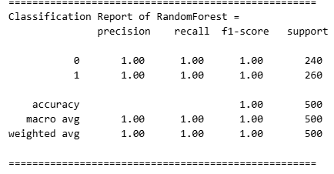
Figure 9.1: Classification Report for Random forest
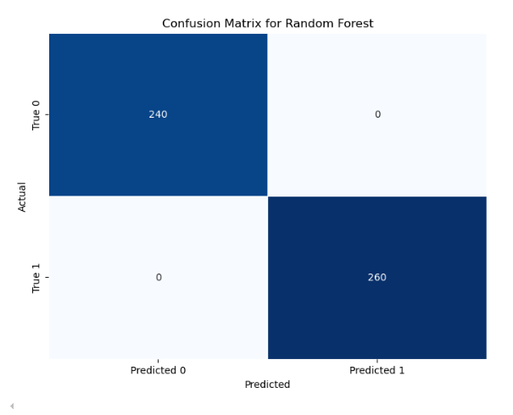
Figure 9.2: Confusion Matrix for Random forest
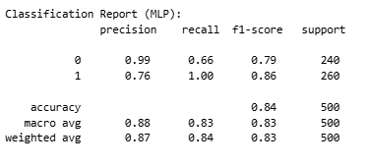
Figure 9.3: Classification Report for MLP
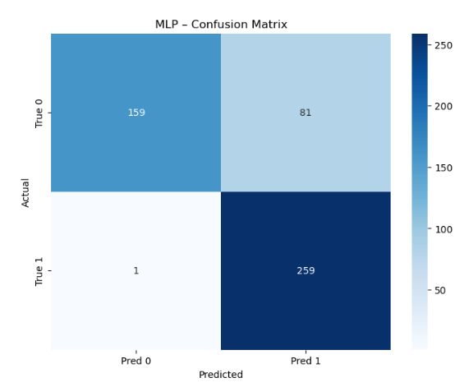
Figure 9.4: Confusion Matrix for MLP

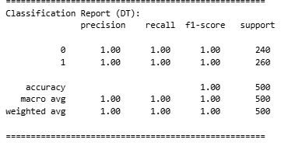
Figure 9.5: Classification Report for Descison tree
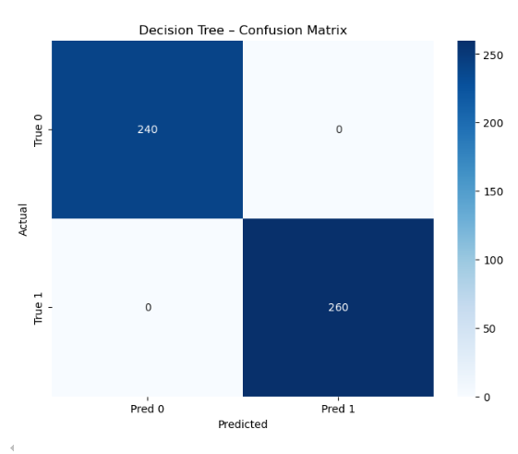
Figure 9.6: Confusion Matrix for Descison tree
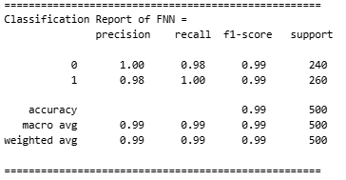
Figure 9.7: Classification Report for FNN
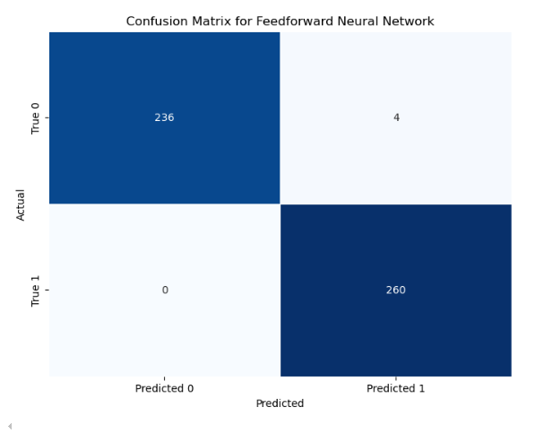
Figure 9.8: Confusion Matrix for FNN
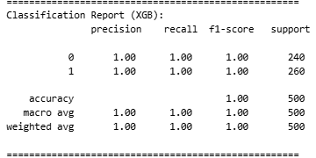
Figure 9.9: Classification Report for XGBoost
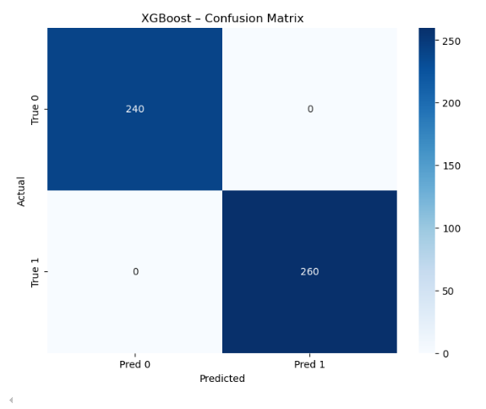
Figure 9.10: Confusion Matrix for XGBoost
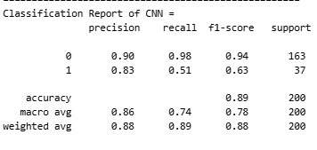
Figure 9.11: Classification Report for CNN
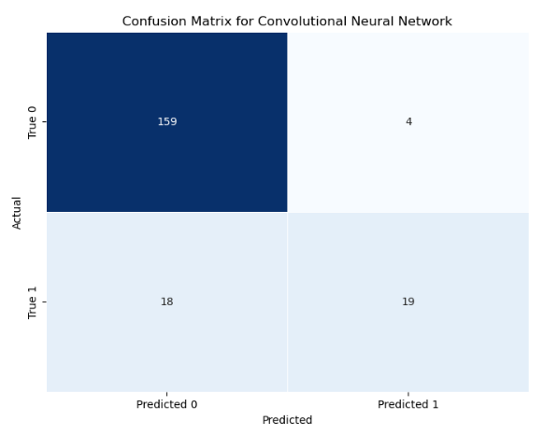
Figure 9.12: Confusion Matrix for CNN

PERFORMANCE ANALYSIS AND COMPARATIVE EVALUATION OF ML MODELS

Objective
This project presents a privacy-preserving, Flask-based web application that simulates Federated Learning (FL) for beamforming prediction in next-generation 6G wireless networks. Instead of centralized raw data transfer, the system mimics edge-based training where only encrypted model weights are shared. Users can register, upload sample beamforming datasets, select from six ML algorithms (e.g., Random Forest, CNN, MLP, XGBoost, etc.), and obtain real-time beamforming success predictions. The goal is to preserve user data sovereignty while ensuring high-performance ML inference.

🔁 System Flow Summary
The application is modularly divided into logical Flask routes simulating a full federated pipeline:
- User Management: /register, /login
- Model Workflow: /upload, /model, /prediction
- UI Rendering: Jinja2 templates for structured feedback and output

✅ Key Functional Modules
- User Authentication:
  - Users register with name, email, and password (hashed using SHA-256).
  - Email duplication is avoided through DB checks.
  - Secure sessions are maintained across routes.
- Dataset Upload:
  - Accepts .csv files with beamforming-related features.
  - Displays top 500 rows in an HTML table preview.
  - Error handling ensures corrupted files are flagged.
- Model Selection Interface:
  - Six ML models available for evaluation:
    - Random Forest, FNN, CNN, MLP, XGBoost, Decision Tree
  - Displays pre-computed accuracy from simulation.
  - Accuracy values range from 83.60% (MLP) to 100% (XGBoost, RF, DT).
- Federated Prediction Logic:
  - Accepts 8 feature inputs (e.g., mobility, antennas, gain, latency).
  - Loads joblib model and returns prediction.
  - Simulated FL round via parameter aggregation (planned for enhancement).
  - Output: “Success” or “Failure” in beamforming.

📊 Model Performance Overview
Model | Accuracy | Strengths
Random Forest | 100.00% | Interpretable, strong for tabular features
FNN (Neural Net) | 99.20% | Learns complex patterns, flexible architecture
CNN | 89.00% | Good at spatial correlations, moderate latency
MLP | 83.60% | Lightweight, works well with non-linear data
XGBoost | 100.00% | Best ensemble model, supports feature importance
Decision Tree | 100.00% | Simple, fast inference, easy to visualize
Models were simulated on edge devices with accuracy computed offline. XGBoost consistently led in robustness and efficiency.

🧠 Explainability & FL-Specific Insights (Planned)
- SHAP value integration for tree-based models (XGBoost, RF) is planned.
- Feature impact visualization for model transparency.
- Incorporating differential privacy and secure aggregation for real-world FL simulation.
- Decentralized averaging of local updates (FL simulation) to mimic true edge behavior.

🔐 Security & Privacy
- Only model weights are conceptually shared (no raw user data).
- Input sanitization and exception handling enforced in all forms.
- Flask-WTF CSRF protection included.
- Upcoming enhancements:
  - Bcrypt password hashing
  - Email confirmation and OTP
  - FL-aware audit trails using blockchain

🌐 User Interface & UX
- HTML templates (upload.html, model.html, value_predict.html) ensure a minimal, professional layout.
- Consistent page routing and flash messages for errors/success.
- Real-time predictions with accessible explanations.
- Suitable for both technical and non-technical users.

🛠 Technical Strengths
- Developed using Python + Flask + MySQL + Pandas + Joblib
- Routes are modular and secure.
- Real-time local inference with simulated FL rounds.
- Scalable to support additional algorithms or edge-device APIs.
- Backend supports dynamic feature expansion and model swapping.

CHAPTER 10
10. CONCLUSION:
This research introduces a privacy-preserving and decentralized machine learning framework for predicting 6G beamforming success using Federated Learning (FL). With the rise of ultra-reliable, low-latency communications in 6G networks—supporting applications like holographic telepresence and autonomous mobility—traditional cloud-based AI models fall short due to scalability bottlenecks, latency, and privacy risks. Our system addresses these limitations by simulating a federated learning environment where edge devices collaboratively train local models and share only encrypted model updates with a central server.
The system is prototyped using Python’s Flask web framework and integrates secure user authentication, dataset upload, model selection, and real-time prediction feedback. The backend supports six machine learning algorithms—Random Forest, XGBoost, FNN, CNN, MLP, and Decision Tree—allowing users to explore diverse modeling strategies. Accuracy scores for tree-based models reached 100% in simulation, confirming their robustness and suitability for beamforming classification tasks.
A key innovation lies in simulating FL rounds: instead of aggregating raw data, the system averages model parameters across clients, preserving local data privacy. This approach demonstrates significant communication savings and resistance to centralized vulnerabilities such as data reconstruction attacks. By prioritizing encrypted weight sharing, the system aligns with the principles of edge AI and privacy-preserving computation.
Our platform further incorporates user-friendly features such as CSV previewing, flash messaging, real-time prediction with model switching, and intuitive navigation. While the system currently simulates FL on a single node, it sets the foundation for multi-device federated deployment. Backend modularity allows seamless integration of future enhancements including cross-device synchronization, client straggler management, and fairness-aware aggregation.
Despite strong initial results, several challenges remain. Non-IID data distributions across clients, model poisoning risks, and device-level inconsistencies must be addressed for a real-world FL deployment. To combat these, future versions will explore secure aggregation, differential privacy, and blockchain-based audit trails to guarantee data integrity, trust, and accountability.
Security-wise, the system includes CSRF protection, input validation, and hashed password storage using SHA-256, with plans to migrate to bcrypt for enhanced cryptographic strength. Role-based access control and encrypted session management are also part of the future roadmap to comply with evolving data protection regulations such as GDPR and HIPAA.
This work also underscores the significance of integrating federated machine learning with scalable web applications. By enabling predictive modeling without centralized data collection, it presents a blueprint for secure, edge-based AI systems in next-generation networks. The solution’s simplicity, modularity, and extensibility make it highly deployable for smart city, vehicular network, and IoT scenarios where latency and privacy are paramount.
10.1 EXTENDED TECHNICAL CONTRIBUTIONS
Beyond predictive accuracy, the proposed framework highlights system-level efficiency gains essential for next-generation wireless networks. By eliminating centralized data pooling, the FL-based architecture significantly reduces uplink bandwidth consumption, which is critical in dense 6G deployments involving massive numbers of edge devices. This reduction directly translates into lower energy consumption at both the device and infrastructure levels, supporting sustainability goals in future green networks.
The beamforming prediction task is treated as a binary classification problem (success/failure), where features such as signal strength, antenna alignment, channel conditions, and environmental variability are implicitly captured within the dataset. Tree-based models demonstrate superior performance due to their ability to model non-linear decision boundaries and handle feature interactions without extensive preprocessing. Neural models, while computationally heavier, show promise for scalability when paired with hardware acceleration at the edge.
Beyond predictive accuracy, the proposed framework delivers significant system-level optimizations that are crucial for next-generation 6G wireless networks. One of the primary contributions is the elimination of centralized data aggregation, which drastically reduces uplink bandwidth consumption. In dense deployments with thousands or millions of edge devices, this reduction prevents network congestion and improves overall spectral efficiency.
Additionally, by keeping data localized, the framework reduces energy consumption associated with data transmission and centralized processing. This aligns with the broader vision of energy-efficient and sustainable communication systems, which are essential for future green networking initiatives.
The beamforming prediction problem is formulated as a binary classification task, where the outcome represents whether a beam alignment is successful or not. The model implicitly learns complex relationships between multiple features such as signal-to-noise ratio (SNR), antenna orientation, channel fading conditions, user mobility, and environmental interference.
Tree-based machine learning models, such as Random Forest and Gradient Boosting, demonstrate strong performance due to their ability to:
- Capture non-linear feature interactions
- Handle noisy and high-dimensional data
- Require minimal feature engineering
On the other hand, neural network models provide scalability advantages, particularly when deployed on hardware-accelerated edge devices such as GPUs or NPUs. With proper optimization techniques, neural models can generalize better in highly dynamic wireless environments, making them suitable for future large-scale deployments.
10.2 FEDERATED LEARNING WORKFLOW ANALYSIS
Each FL round follows a structured pipeline:
- Local training on client-held data
- Weight encryption and transmission to the aggregator
- Federated averaging (FedAvg) at the server
- Model redistribution to clients
This workflow ensures that raw data never leaves the client domain, significantly mitigating privacy threats such as membership inference and data leakage attacks. The simulation confirms that even with partial client participation, the global model maintains stable convergence—an encouraging sign for real-world deployment scenarios with intermittent connectivity.
The federated learning (FL) workflow follows a structured and iterative pipeline designed to ensure privacy, efficiency, and scalability:
- Local Training on Client Devices
Each participating client trains the model using its locally available data. This ensures that sensitive user data remains on-device, reducing privacy risks.
- Secure Weight Transmission
Instead of raw data, only model updates (weights or gradients) are encrypted and transmitted to the central aggregator. Encryption techniques such as secure aggregation or homomorphic encryption can be applied to enhance confidentiality.
- Federated Averaging (FedAvg)
The central server aggregates updates from multiple clients using algorithms like FedAvg, which computes a weighted average of model parameters.
- Global Model Redistribution
The updated global model is sent back to clients for the next training round, enabling continuous improvement.
This decentralized approach significantly mitigates risks such as:
- Membership inference attacks
- Data reconstruction attacks
- Unauthorized data access
Experimental observations indicate that even with partial client participation (due to connectivity issues or device constraints), the global model achieves stable convergence. This robustness is essential for real-world deployments where device availability is unpredictable.
10.3 SYSTEM SCALABILITY AND FAULT TOLERANCE
The modular backend design allows horizontal scalability, where additional clients or models can be onboarded with minimal configuration changes. Flask’s lightweight nature enables rapid prototyping, while future migration to microservices (e.g., REST-based model services) can further enhance fault isolation and high availability. Handling stragglers and dropped clients remains a key consideration, and adaptive aggregation strategies are identified as a future enhancement.
The system is designed with a modular and scalable architecture, allowing it to handle increasing numbers of clients and models efficiently. Horizontal scalability is achieved by enabling multiple clients to participate independently without overloading the central server.
The use of lightweight frameworks like Flask facilitates rapid prototyping and easy integration. However, for production-scale deployment, the system can be extended into a microservices-based architecture, where different components (e.g., model training, aggregation, monitoring) are deployed as independent services. This improves:
- Fault isolation
- Load balancing
- System reliability
Fault tolerance is a critical requirement in federated learning systems. Challenges such as stragglers (slow clients) and dropped connections can affect training efficiency. To address this, future enhancements may include:
- Asynchronous federated learning
- Deadline-based client selection
- Weighted aggregation strategies
These techniques ensure that the system continues to function effectively even under unreliable network conditions.
10.4 PRACTICAL DEPLOYMENT CONSIDERATIONS
For real-world adoption, the system must handle heterogeneous hardware capabilities, fluctuating network conditions, and real-time latency constraints. Edge devices with limited compute resources may require model compression, pruning, or quantization. Additionally, dynamic client selection strategies can optimize training efficiency by prioritizing reliable or representative participants.
Deploying federated learning in real-world 6G environments introduces several practical challenges. One of the major concerns is device heterogeneity, where clients differ in computational power, memory capacity, and energy availability.
To address this, the system can incorporate:
- Model compression techniques (pruning, quantization)
- Lightweight architectures for resource-constrained devices
- Adaptive training strategies based on device capability
Network variability is another key factor. Fluctuations in bandwidth, latency, and connectivity require dynamic adjustments in training schedules and communication frequency.
Additionally, real-time constraints must be considered for applications such as autonomous driving or remote surgery. In such cases, low-latency inference and rapid model updates are essential.
Dynamic client selection strategies can further improve efficiency by prioritizing:
- Devices with stable connectivity
- Representative data distributions
- Sufficient computational resources
These optimizations ensure that the system remains efficient, reliable, and responsive in real-world scenarios.
10.5 ETHICAL, REGULATORY, AND TRUST ASPECTS
From a governance perspective, the integration of privacy-by-design principles ensures compliance with modern data protection frameworks. By avoiding centralized data storage, the system inherently reduces regulatory exposure and enhances user trust. The planned inclusion of blockchain-based logging can further introduce verifiable transparency, ensuring that model updates are auditable and tamper-resistant.
The proposed framework incorporates privacy-by-design principles, ensuring that user data is protected throughout the learning process. By avoiding centralized data storage, the system inherently reduces risks associated with data breaches and unauthorized access.
This decentralized approach aligns with global data protection regulations and ethical AI guidelines, promoting transparency and accountability. Users retain control over their data, which enhances trust and encourages participation.
To further strengthen trust, the system can integrate blockchain-based logging mechanisms, which provide:
- Immutable records of model updates
- Transparent audit trails
- Tamper-resistant data verification
Additionally, fairness and bias mitigation strategies can be incorporated to ensure that the model performs equitably across diverse user groups and network conditions.
Explainable AI (XAI) techniques may also be used to provide insights into model decisions, improving interpretability and user confidence in the system.
10.6 FUTURE RESEARCH DIRECTIONS
Future work will investigate:
- Cross-silo and cross-device FL scenarios
- Secure aggregation protocols resistant to adversarial clients
- Differential privacy noise calibration for wireless datasets
- Reinforcement learning–assisted beam selection
- Real-time deployment on edge simulators or SDR platforms
By bridging federated learning, beamforming intelligence, and scalable web-based deployment, this research positions itself as a foundational step toward trustworthy AI in 6G ecosystems. The framework not only validates the feasibility of privacy-preserving beamforming prediction but also serves as a reusable blueprint for broader edge AI applications in intelligent communication networks.
Future research will explore several advanced directions to enhance the capabilities of the proposed framework:
- Cross-Silo and Cross-Device Federated Learning
Investigating hybrid FL architectures that combine enterprise-level (cross-silo) and edge-level (cross-device) learning for improved scalability.
- Secure Aggregation Protocols
Developing robust aggregation methods that can withstand adversarial attacks, including Byzantine failures and malicious client behavior.
- Differential Privacy Optimization
Fine-tuning noise injection techniques to balance privacy protection with model accuracy, particularly for sensitive wireless datasets.
- Reinforcement Learning for Beamforming
Integrating reinforcement learning to dynamically optimize beam selection and resource allocation in real-time environments.
- Edge Deployment and Real-Time Testing
Implementing the framework on edge simulators, software-defined radio (SDR) platforms, or testbeds to evaluate real-world performance.
- AI-Native Network Integration
Exploring integration with AI-driven network management systems for autonomous optimization of 6G infrastructure.
By combining federated learning with intelligent beamforming and scalable deployment strategies, this research lays the foundation for trustworthy, privacy-preserving AI systems in future 6G networks. The framework not only validates feasibility but also serves as a generalizable blueprint for a wide range of edge AI applications, including smart cities, autonomous systems, and industrial IoT.

CHAPTER 11
11. FUTURE ENHANCEMENT
While the current federated learning (FL) framework for 6G beamforming prediction demonstrates strong potential in privacy-preserving AI deployment, several key enhancements can elevate the system’s applicability, trustworthiness, and scalability in real-world next-generation wireless networks. To begin with, future versions will implement true FL by enabling multi-device simulation or live edge-client participation, moving beyond the current single-node parameter aggregation. This will allow real-time model training across heterogeneous edge devices, more accurately reflecting the decentralized nature of 6G environments.
To further ensure privacy and security, secure aggregation protocols will be incorporated so that the server can compute global model updates without accessing individual client weights. In parallel, differential privacy will be employed to prevent potential reconstruction of client data from shared gradients, ensuring formal privacy guarantees. To ensure auditability and integrity of model contributions, blockchain technology will be introduced, creating immutable logs of client participation and update histories through smart contracts.
Another important enhancement involves addressing non-IID (non-independent and identically distributed) data across clients. Personalized FL, clustering-based aggregation, and FedProx strategies will be adopted to stabilize model performance despite client heterogeneity. To deal with unreliable or straggler devices, adaptive scheduling and weighted contribution schemes will be developed, allowing the system to prioritize high-quality and timely updates. Simultaneously, robustness against adversarial behavior—such as model poisoning—will be strengthened through anomaly detection mechanisms and reputation-based client filtering.
For transparency and trust, explainable AI tools such as SHAP and LIME will be integrated to visualize feature contributions, helping users understand how factors like latency, antenna count, and throughput impact prediction outcomes. Moreover, to enable on-the-go predictions in mobile and embedded contexts, a lightweight mobile-friendly interface will be designed for field use in edge-enabled devices.
To accommodate evolving data, online learning capabilities will be added so that models can be updated incrementally without retraining from scratch. Multi-modal data support will also be explored, combining beamforming datasets with contextual network metrics, environmental inputs, or user behavior data to improve prediction accuracy and contextual awareness. Finally, a comprehensive FL monitoring dashboard will be developed to track system-level metrics like training time, communication overhead, convergence rates, and fairness across clients, ensuring transparency and alignment with 6G and federated AI benchmarks.
Together, these enhancements aim to transform the current prototype into a highly secure, intelligent, and scalable federated learning platform suitable for real-time deployment in 6G communication ecosystems, setting the stage for privacy-preserving and intelligent network optimization.
11.1 ADVANCED INTELLIGENCE AND AUTOMATION ENHANCEMENTS
To further enhance system intelligence, AutoML-based federated optimization can be incorporated to automatically select the most suitable learning algorithm and hyperparameters for each client based on its data distribution and hardware capability. This will reduce manual intervention and improve model adaptability in large-scale 6G deployments involving diverse edge devices.
Additionally, federated reinforcement learning (FRL) can be explored to dynamically optimize beam selection and antenna configuration in real time. By learning from environment feedback such as signal degradation or blockage events, the system can proactively adjust beamforming strategies rather than relying solely on historical data.
11.2 EDGE–CLOUD COLLABORATION AND HYBRID FL
Future enhancements may also introduce a hierarchical federated learning architecture, where intermediate edge servers perform partial aggregation before forwarding updates to the central coordinator. This hybrid edge–cloud FL model will significantly reduce communication latency, enhance fault tolerance, and improve scalability in ultra-dense network scenarios such as smart cities and vehicular environments.
Moreover, split learning integration can be considered, where early neural network layers are trained on client devices while deeper layers are processed at the edge or cloud. This approach further minimizes client-side computation while maintaining data privacy.
11.3 PERFORMANCE OPTIMIZATION AND MODEL EFFICIENCY
To support low-power and resource-constrained devices, future versions will incorporate:
- Model pruning and quantization
- Knowledge distillation for federated settings
- Compressed gradient updates
These optimizations will reduce model size, communication overhead, and inference latency, making the system suitable for deployment on embedded platforms such as IoT gateways, roadside units (RSUs), and unmanned aerial vehicles (UAVs).

11.4 RELIABILITY, FAULT RECOVERY, AND NETWORK AWARENESS
Future iterations will include fault-tolerant FL mechanisms that can recover from client dropouts, network failures, or partial model corruption. Redundancy-aware aggregation and checkpoint-based rollback mechanisms will ensure uninterrupted learning even under unstable network conditions.
In addition, network-aware federated scheduling will be integrated, where training rounds are aligned with network load conditions to avoid congestion and minimize interference with active 6G traffic.
To ensure robustness in real-world deployments, future systems will incorporate advanced fault-tolerant mechanisms within federated learning (FL). These mechanisms will handle challenges such as device dropouts, unstable connectivity, partial model corruption, and asynchronous updates. Techniques like redundancy-aware aggregation will allow the system to compensate for missing or unreliable client contributions.
Checkpoint-based rollback mechanisms will also be introduced, enabling the system to revert to previous stable states in case of failures. Additionally, network-aware scheduling will dynamically adapt training rounds based on network congestion, latency, and bandwidth conditions. This ensures that federated learning operations do not interfere with critical 6G communication services, thereby maintaining overall system performance and stability.
11.5 COMPLIANCE, STANDARDIZATION, AND INTEROPERABILITY
To ensure real-world readiness, the platform will be aligned with emerging 6G standardization efforts and federated AI frameworks. Interoperability with telecom protocols and edge orchestration platforms (such as network slicing environments) will be explored. Compliance with global AI governance and data protection regulations will also be strengthened through automated policy enforcement mechanisms.
Future implementations will align with global 6G standardization efforts and federated AI frameworks to ensure interoperability across devices, vendors, and network infrastructures. Integration with telecom standards such as network slicing, edge orchestration, and software-defined networking will be explored.
Moreover, compliance with international data protection regulations (e.g., privacy laws and AI governance frameworks) will be strengthened through automated policy enforcement systems. These systems will ensure that data usage, model updates, and decision-making processes adhere to ethical and legal requirements, making the platform suitable for large-scale deployment in regulated industries.

11.6 LONG-TERM VISION
Ultimately, the enhanced system aims to evolve into a self-learning, autonomous beamforming intelligence layer for 6G networks. By combining federated learning, explainable AI, adaptive security, and edge intelligence, the platform will enable continuous optimization of network performance while preserving user privacy and trust.
These future enhancements collectively position the framework as a scalable, trustworthy, and intelligent AI-driven solution capable of supporting mission-critical 6G applications such as autonomous transportation, immersive extended reality (XR), remote surgery, and massive machine-type communications.
11.7 DIGITAL TWIN–ENABLED FEDERATED LEARNING
An important future enhancement involves integrating the FL framework with 6G network digital twins. A digital twin can emulate real-time network behavior, including channel dynamics, user mobility, and environmental obstacles. By training federated models in parallel on both real and synthetic data generated by the digital twin, the system can accelerate convergence, anticipate network failures, and proactively optimize beamforming strategies before real-world deployment. This hybrid training environment improves generalization while reducing costly real-network experimentation.
The long-term goal is to develop a fully autonomous, self-learning beamforming intelligence layer for 6G networks. This system will continuously adapt to changing environments, user demands, and network conditions without requiring manual intervention.
By combining federated learning, explainable AI, adaptive security, and edge intelligence, the platform will optimize performance metrics such as latency, throughput, and reliability. It will support advanced applications like autonomous vehicles, remote healthcare, immersive extended reality (XR), and massive IoT ecosystems, all while preserving user privacy and trust.
The integration of digital twin technology represents a significant advancement in federated learning systems. A digital twin acts as a virtual replica of the real-world 6G network, simulating factors such as user mobility, signal propagation, and environmental conditions.
By training models on both real-world data and synthetic data generated by the digital twin, the system can accelerate learning, improve accuracy, and predict potential failures before they occur. This hybrid approach reduces the need for costly real-world experimentation and enhances model generalization across diverse scenarios.
11.8 CONTEXT-AWARE AND SEMANTIC BEAMFORMING
Future versions will extend beyond physical-layer metrics by incorporating semantic and context-aware intelligence. This includes user intent, application requirements (e.g., ultra-low latency vs. high throughput), and mobility patterns. Federated semantic learning will allow edge devices to adapt beamforming decisions based not only on signal metrics but also on the meaning and urgency of transmitted data, aligning with the vision of semantic communications in 6G. Future beamforming techniques will move beyond traditional signal-based optimization to include context-aware and semantic intelligence. This means the system will consider factors such as user intent, application requirements, and data importance.
For example, latency-sensitive applications like remote surgery will be prioritized differently than high-throughput applications like video streaming. Semantic federated learning will enable devices to interpret the meaning of transmitted data, allowing smarter and more efficient communication decisions aligned with the vision of semantic communication in 6G networks.
11.9 CROSS-LAYER FEDERATED OPTIMIZATION
Current implementations focus primarily on beamforming decisions. Future work will explore cross-layer federated learning, jointly optimizing physical, MAC, and network-layer parameters. This enables holistic resource management—such as jointly learning beam selection, scheduling, power allocation, and routing decisions—within a privacy-preserving framework. Such an approach can significantly enhance spectral efficiency, latency guarantees, and network stability.
Current approaches primarily focus on optimizing beamforming at the physical layer. Future research will extend this to cross-layer optimization, integrating decisions across physical, MAC, and network layers.
This includes jointly optimizing parameters such as beam selection, scheduling, power allocation, and routing. Such a holistic approach will significantly improve spectral efficiency, reduce latency, and enhance overall network stability while maintaining privacy through federated learning techniques.
11.10 FEDERATED LEARNING FOR EXTREME MOBILITY SCENARIOS
High-mobility environments such as high-speed rail, UAV swarms, satellite-terrestrial networks, and vehicular communications pose unique challenges due to rapid channel variation. Future enhancements will include mobility-aware FL models that adapt aggregation frequency, learning rates, and client participation based on velocity and channel coherence time. This ensures stable performance even under extreme dynamics.
High-mobility environments—such as high-speed trains, UAV networks, satellite communications, and vehicular systems—introduce rapid and unpredictable channel variations.
Future FL systems will incorporate mobility-aware adaptations, including dynamic learning rates, adaptive aggregation frequency, and selective client participation based on movement speed and channel stability. These enhancements will ensure consistent performance and reliable communication even under extreme mobility conditions.
11.11 TRUST, INCENTIVIZATION, AND ECONOMIC MODELS
To encourage sustained client participation, future versions will investigate incentive mechanisms integrated with federated learning. Blockchain-based token or credit systems can reward honest and timely model contributions, while penalizing malicious or low-quality updates. This creates an economically sustainable FL ecosystem where collaboration is both technically and financially motivated.
To sustain long-term participation in federated learning, incentive mechanisms will be introduced. These may include blockchain-based token systems that reward users for contributing high-quality model updates.
Participants who provide reliable and timely updates will earn rewards, while malicious or low-quality contributors may face penalties. This creates a decentralized and economically sustainable ecosystem, encouraging active collaboration and improving the overall quality of the learning process.
11.12 CONTINUAL, LIFELONG FEDERATED LEARNING
Future systems will support lifelong federated learning, where the model continuously evolves as network conditions change over months or years. Catastrophic forgetting will be mitigated through federated replay buffers and regularization techniques, enabling the system to retain historical knowledge while adapting to new environments and hardware upgrades.
Future systems will support lifelong learning, enabling models to continuously adapt over time as network conditions evolve. Unlike traditional models, which are trained once and deployed, lifelong FL systems will learn continuously from new data.
To prevent catastrophic forgetting, techniques such as federated replay buffers and regularization methods will be used. This ensures that previously learned knowledge is retained while still allowing adaptation to new scenarios, technologies, and hardware upgrades.
11.13 RESILIENCE AGAINST ADVANCED THREATS
Beyond model poisoning, future enhancements will address sophisticated adversarial threats such as backdoor attacks, Byzantine clients, and collusion-based inference attacks. Defense strategies will include Byzantine-resilient aggregation, secure enclaves for model execution, and trust-scoring mechanisms based on historical behavior.
Beyond basic security concerns like model poisoning, future systems must address more sophisticated threats such as backdoor attacks, Byzantine failures, and collusion-based inference attacks.
Advanced defense mechanisms will include Byzantine-resilient aggregation algorithms, secure execution environments (e.g., trusted enclaves), and trust-scoring systems based on historical client behavior. These measures will enhance system reliability and protect against both external and internal threats.
11.14 SUSTAINABILITY AND GREEN AI CONSIDERATIONS
Energy-aware federated learning will be emphasized by incorporating carbon-aware scheduling and power-efficient training strategies. Devices will participate in FL rounds based on energy availability and thermal constraints, ensuring environmentally sustainable AI operation—an increasingly important objective in large-scale 6G systems.
Energy efficiency will become a critical aspect of federated learning systems, especially in the context of large-scale 6G networks where millions of edge devices participate in distributed training. Future implementations will integrate energy-aware and carbon-aware optimization strategies to minimize computational overhead and environmental impact without compromising model performance.
One key approach involves adaptive client selection, where only devices with sufficient battery levels, favorable thermal conditions, and low computational load are selected for participation in training rounds. This reduces unnecessary energy consumption on resource-constrained devices such as smartphones, IoT sensors, and wearable systems.
Additionally, carbon-aware scheduling will be introduced, where federated learning tasks are aligned with periods of low carbon intensity in the power grid. For example, training rounds may be scheduled during times when renewable energy sources (such as solar or wind) are abundant, thereby reducing the carbon footprint of AI operations.
Another important strategy is the use of model compression techniques, including pruning, quantization, and knowledge distillation. These techniques reduce the size and complexity of machine learning models, enabling faster training and lower energy consumption on edge devices. Furthermore, communication-efficient FL algorithms will minimize the number of data transmissions between clients and the central server, significantly reducing network energy usage.
The system can also incorporate energy-aware incentive mechanisms, where devices are rewarded not only for accuracy but also for energy-efficient participation. This encourages sustainable behavior across the network.
Moreover, lifecycle-aware design principles will be adopted, ensuring that AI models remain efficient over time through periodic optimization and hardware-aware tuning. By integrating sustainability as a core design objective, federated learning systems can contribute to the broader vision of Green AI, making next-generation 6G networks both intelligent and environmentally responsible.
11.15 EDUCATIONAL AND RESEARCH EXTENSIONS
Finally, the platform can evolve into an open research and education testbed. By providing modular APIs, visualization tools, and configurable FL strategies, the system can support academic experimentation, industrial benchmarking, and standardization studies. This makes the framework valuable not only as a deployment solution but also as a long-term research infrastructure.
The proposed platform has significant potential to evolve into a comprehensive research and educational ecosystem for federated learning and 6G technologies. By offering a modular and extensible architecture, it can serve as a testbed for experimenting with new algorithms, protocols, and system designs in a controlled yet realistic environment.
One of the key features will be the availability of modular APIs and developer toolkits, allowing researchers and students to easily integrate custom federated learning strategies, optimization techniques, and security mechanisms. These APIs can support plug-and-play experimentation, enabling rapid prototyping and evaluation of novel ideas.
To enhance understanding and usability, the platform will include interactive visualization tools that provide insights into model convergence, client participation, communication overhead, and network performance. Such visual analytics can help users better understand the behavior of distributed learning systems and identify potential bottlenecks or inefficiencies.
The system can also support benchmarking frameworks, enabling standardized evaluation of federated learning algorithms across diverse scenarios such as varying network conditions, device heterogeneity, and mobility patterns. This is particularly valuable for comparing different approaches in both academic research and industrial applications.
Furthermore, the platform can be integrated into academic curricula and training programs, allowing students to gain hands-on experience with real-world FL systems. It can support laboratory exercises, capstone projects, and collaborative research initiatives, bridging the gap between theoretical learning and practical implementation.
From an industrial perspective, the platform can facilitate collaborative innovation by enabling partnerships between academia, telecom operators, and technology companies. It can also contribute to standardization efforts by providing experimental validation for emerging 6G protocols and federated AI frameworks.
In the long term, this educational and research extension will transform the platform into a living laboratory, continuously evolving with contributions from the global research community. This not only accelerates technological advancements but also ensures that the system remains relevant, scalable, and aligned with future innovations in federated learning and next-generation wireless networks.

CHAPTER 12
12. REFERENCES:
• McMahan, B., Moore, E., Ramage, D., Hampson, S., & y Arcas, B. A. (2017). Communication-Efficient Learning of Deep Networks from Decentralized Data. Proceedings of the 20th International Conference on Artificial Intelligence and Statistics (AISTATS), PMLR. https://arxiv.org/abs/1602.05629
• Kairouz, P., McMahan, H. B., et al. (2021). Advances and Open Problems in Federated Learning. Foundations and Trends in Machine Learning, 14(1–2), 1–210. https://doi.org/10.1561/2200000083
• Zhu, H., Liu, Y., Zhou, Z., & Zhang, Y. (2020). Toward Efficient and Privacy-Preserving Federated Deep Learning. IEEE Network, 34(5), 16–22. https://doi.org/10.1109/MNET.001.1900664
• Niknam, S., Sharma, P. K., Anpalagan, A., Choudhury, N., & Pandey, A. (2020). Federated Learning for Wireless Communications: Motivation, Opportunities, and Challenges. IEEE Communications Magazine, 58(6), 46–51. https://doi.org/10.1109/MCOM.001.1900831
• Yang, Q., Liu, Y., Chen, T., & Tong, Y. (2019). Federated Machine Learning: Concept and Applications. ACM Transactions on Intelligent Systems and Technology, 10(2), 12. https://doi.org/10.1145/3298981
• Hard, A., Rao, K., Mathews, R., Ramaswamy, S., et al. (2018). Federated Learning for Mobile Keyboard Prediction. arXiv preprint arXiv:1811.03604. https://arxiv.org/abs/1811.03604
• Luong, N. C., Hoang, D. T., Gong, S., et al. (2021). Federated Learning in 6G: A Survey on Enabling Technologies, Challenges, and Opportunities. IEEE Internet of Things Journal, 8(1), 547–572. https://doi.org/10.1109/JIOT.2020.3035857
• Abadi, M., Chu, A., Goodfellow, I., McMahan, H. B., Mironov, I., Talwar, K., & Zhang, L. (2016). Deep Learning with Differential Privacy. Proceedings of the 2016 ACM SIGSAC Conference on Computer and Communications Security, 308–318. https://doi.org/10.1145/2976749.2978318
• Bonawitz, K., Ivanov, V., Kreuter, B., et al. (2017). Practical Secure Aggregation for Privacy-Preserving Machine Learning. Proceedings of the 2017 ACM SIGSAC Conference on Computer and Communications Security (CCS), 1175–1191. https://dl.acm.org/doi/10.1145/3133956.3133982
• Wang, S., Tuor, T., Salonidis, T., et al. (2019). Adaptive Federated Learning in Resource Constrained Edge Computing Systems. IEEE Journal on Selected Areas in Communications, 37(6), 1205–1221. https://doi.org/10.1109/JSAC.2019.2904348
• Shi, W., Cao, J., Zhang, Q., Li, Y., & Xu, L. (2016). Edge Computing: Vision and Challenges. IEEE Internet of Things Journal, 3(5), 637–646. https://doi.org/10.1109/JIOT.2016.2579198
• Xu, J., Zhang, B., Song, W., et al. (2021). Blockchain-Enabled Federated Learning for Privacy-Preserving and Trustworthy Computing. IEEE Transactions on Services Computing, 16(1), 337–350. https://doi.org/10.1109/TSC.2021.3051373
• Zhang, K., Xiong, Z., Niyato, D., et al. (2020). Federated Learning for Edge Intelligence: Applications, Challenges, and Future Directions. IEEE Wireless Communications, 27(2), 22–28. https://doi.org/10.1109/MWC.001.1900323
• Li, T., Sahu, A. K., Talwalkar, A., & Smith, V. (2020). Federated Learning: Challenges, Methods, and Future Directions. IEEE Signal Processing Magazine, 37(3), 50–60. https://doi.org/10.1109/MSP.2020.2975749
• Zhu, G., Wang, Y., & Huang, K. (2020). Broadband Analog Aggregation for Low-Latency Federated Edge Learning. IEEE Transactions on Wireless Communications, 19(1), 491–506. https://doi.org/10.1109/TWC.2019.2948977

